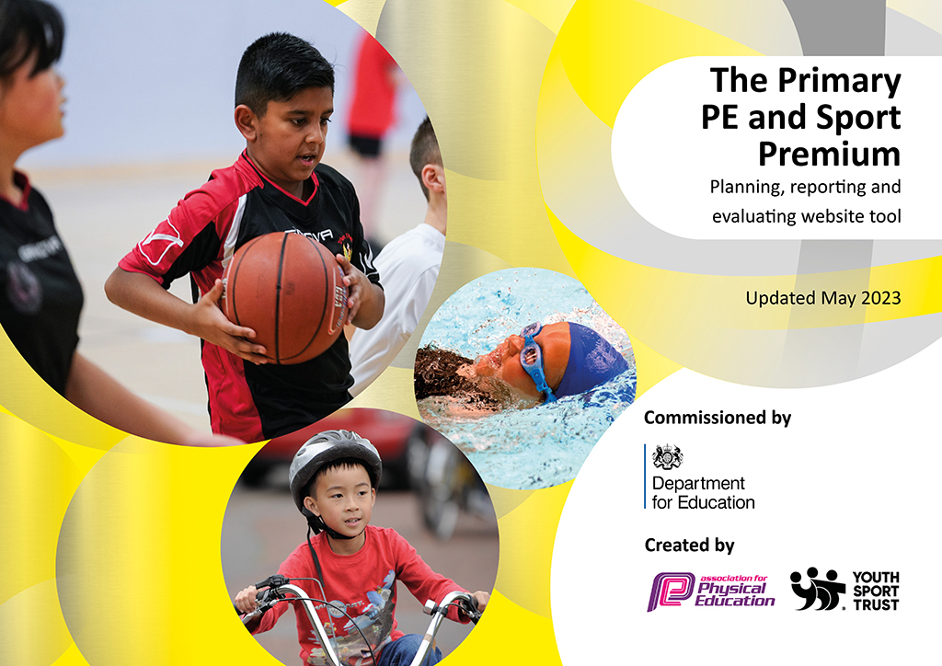
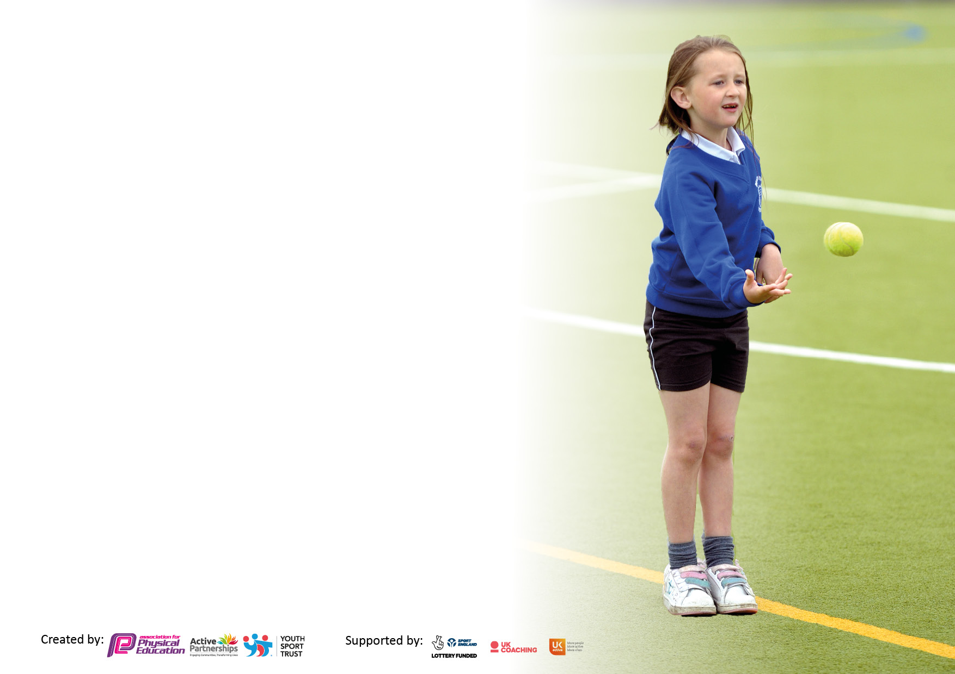

It is important that your grant is used effectively and based on school need. The Education Inspection Framework makes clear there will be a focus on ‘whether leaders and those responsible for governors all understand their respective roles and perform these in a way that enhances the effectiveness of the school’.

Under the Quality of Education Ofsted inspectors consider:
Intent - Curriculum design, coverage and appropriateness
Implementation - Curriculum delivery, Teaching (pedagogy) and Assessment
Impact - Attainment and progress

To assist schools with common transferable language this template has been developed to utilise the same three headings which should make your plans easily transferable between working documents.

Schools must use the funding to make additional and sustainable improvements to the quality of Physical Education, School Sport and Physical Activity (PESSPA) they offer. This means that you should use the Primary PE and sport premium to:

- Develop or add to the PESSPA activities that your school already offer
- Build capacity and capability within the school to ensure that improvements made now will benefit pupils joining the school in future years
- The Primary PE and sport premium should not be used to fund capital spend projects; the school’s budget should fund these.

Please visit gov.uk for the revised DfE guidance including the5keyindicatorsacrosswhichschoolsshoulddemonstrate an improvement. This document will helpyoutoreviewyourprovisionandtoreportyourspend.DfEencouragesschools to use this template as an effective way of meeting the reporting requirements of the Primary PE and Sport Premium.

We recommend you start by reflecting on the impact of current provision and reviewing the previous spend.

Schools are required to publish details of how they spend this funding, including any under-spend from 2021/2022, as well as on the impact it has on pupils’ PE and sport participation and attainment. The funding should be spent by 31st July but the DfE has stated that there will be no clawback of any unspent money so this can be carried forward into 2023/24.

We recommend regularly updating the table and publishing it on your website throughout the year. This evidences your ongoing self-evaluation of how you are using the funding to secure maximum, sustainable impact. Final copy must be posted on your website by the end of the academic year and no later than the 31st July 2023. To see an example of how to complete the table please click HERE.

Details with regard to funding
Please complete the table below.

Total amount carried over from 2020/21 | £17248
Total amount allocated for 2021/22 | £19628
How much (if any) do you intend to carry over from this total fund into 2022/23? | £0
Total amount allocated for 2022/23 | £19578
Total amount of funding for 2022/23. Ideally should be spent and reported on by 31st July 2023. | £19578
Swimming Data
Please report on your Swimming Data below.

Meeting national curriculum requirements for swimming and water safety.

N.B. Complete this section to your best ability. For example you might have practised safe self-rescue techniques on dry land which you can then transfer to the pool when school swimming restarts.
Due to exceptional circumstances priority should be given to ensuring that pupils can perform safe self rescue even if they do not fully meet the first two requirements of the NC programme of study
What percentage of your current Year 6 cohort swim competently, confidently and proficiently over a distance of at least 25 metres?  N.B. Even though your pupils may swim in another year please report on their attainment on leaving primary school at the end of the summer term 2023.  Please see note above | 65%
What percentage of your current Year 6 cohort use a range of strokes effectively [for example, front crawl, backstroke and breaststroke]?  Please see note above | 68%
What percentage of your current Year 6 cohort perform safe self-rescue in different water-based situations? | 75%
Schools can choose to use the Primary PE and sport premium to provide additional provision for swimming but this must be for activity over and above the national curriculum requirements. Have you used it in this way? | Yes

Action Plan and Budget Tracking
Capture your intended annual spend against the 5 key indicators. Clarify the success criteria and evidence of impact that you intend to measure to evaluate for pupils today and for the future.

Academic Year: 2022/23 | Total fund allocated: | Date Updated:
Key indicator 1: The engagement of all pupils in regular physical activity – Chief Medical Officers guidelines recommend that primary school pupils undertake at least 30 minutes of physical activity a day in school |  |  |  | Percentage of total allocation:
 |  |  |  | 44%
Intent | Implementation |  | Impact
Your school focus should be clear what you want the pupils to know and be able to do and about  what they need to learn and to  consolidate through practice: | Make sure your actions to achieve are linked to your intentions: | Funding allocated: | Evidence of impact: what do pupils now know and what can they now do? What has changed?: | Sustainability and suggested next steps:
Resources to encourage children to be active at playtime and lunchtime. | New equipment for each phase to be used at playtimes. Including a new wooden games board. | £1173 | Children are involved in choosing their equipment in order to encourage them to use the resources available to them. | Children are given the responsibility (with the support of staff) of looking after their phase’s equipment.
Equipment to provide children with a variety to skills academy clubs. | Sports coaches liaised with staff and children about what skills club to offer. Equipment to facilitate clubs. | £343 | Percentage of children choosing an active skills academy increased their active week by an hour:  Autumn Term:61%  Spring Term:66%  Summer Term:73% | Continue to include children in choosing what skills academy groups are on offer in order to continue to increase participation.
Lunchtime clubs offered by qualified sports coach. | Children are encouraged to buy a variety of different sports during break and lunchtimes. | £4475 | 72% of children in KS2 have attended a physically active club over the year for at least a half term. | Dinner ladies have observed sessions so can replicate on other days.
Increased participation of younger children during free times using sports leaders from Year 6. | Sports leaders course for children. Supporting younger children in KS1 and LKS2. | £240 | X10 children took on the role of sports leaders.  All of KS1 and LKS2 have been offered activities led by the older children. | The current year six children have passed on their roles and responsibilities to year 5.
Active families. | Children and their families were invited to a Saturday morning running event at school. Other equipment was available for families to use with staff modelling how to be active at home. | £300  Staffing costs | Over 200 people attended the event. Parental feedback was very positive. | Resourcing the event will incur similar costs.
Scooter Day | All children from Rec to Y6 took part in a scooter day held by Scootfit. | £1320 | All children took part in the event learning new skills which they can then use at home on their own scooters. | Review next year with pupil voice as to whether repeat event.
Experiencing alternative sports | Equipment purchased for boxing and basketball. | £865 | Skills academy and after school clubs offered.  Boxing: 56 children  Basketball: 135 | Continue to encourage children to be active in different ways. Equipment can be used again next year.
Key indicator 2: The profile of PESSPA being raised across the school as a tool for whole school improvement |  |  |  | Percentage of total allocation:
 |  |  |  | 22%
Intent | Implementation |  | Impact
Your school focus should be clear what you want the pupils to know and be able to do and about  what they need to learn and to  consolidate through practice: | Make sure your actions to achieve are linked to your intentions: | Funding allocated: | Evidence of impact: what do pupils now know and what can they now do? What has changed?: | Sustainability and suggested next steps:
Increase children’s interest in sports and gaining knowledge of professional stars and role models. | Sporting books in library | £130 | Children have access to and read books daily. | Books will need to be updated regularly.
Active teaching and learning | Teach Active Maths | £575 | Children in KS2 engage in active maths lessons x1 every fortnight. | Embedding it into the curriculum . Monitored by PE and Maths lead.
Children to be given opportunities to be active when caring and developing their environment. | Biodome supplies. Activities include digging, weeding, raking etc. | £1000 | Children in Y1, 3, 5 use the biodome for a term. Year 2 and 6 for half a term. | Supplies will need to be updated but the produce will continue to grow.
Active play in Reception | Children given the opportunity to use and play with different equipment to encourage learning through active play. | £2820 | Reception and KS1 children have access to this new wooden equipment. | Sustainable resources purchased.

Key indicator 3: Increased confidence, knowledge and skills of all staff in teaching PE and sport |  |  |  | Percentage of total allocation:
 |  |  |  | 2%
Intent | Implementation |  | Impact
Your school focus should be clear | Make sure your actions to | Funding | Evidence of impact: what do | Sustainability and suggested
what you want the pupils to know | achieve are linked to your | allocated: | pupils now know and what | next steps:
and be able to do and about | intentions: |  | can they now do? What has
what they need to learn and to |  |  | changed?:
consolidate through practice:
Support from Youth Sports Trust | Membership and support package | £435 | PE lead and inhouse sports coach have accessed resources in order to support development of PE across the school. | Knowledge gained and shared.
Key indicator 4: Broader experience of a range of sports and activities offered to all pupils |  |  |  | Percentage of total allocation:
 |  |  |  | 18%
Intent | Implementation |  | Impact
Your school focus should be clear | Make sure your actions to | Funding | Evidence of impact: what do | Sustainability and suggested
what you want the pupils to know | achieve are linked to your | allocated: | pupils now know and what | next steps:
and be able to do and about | intentions: |  | can they now do? What has
what they need to learn and to |  |  | changed?:
consolidate through practice:
To enable children to leave primary school with the minimum swimming requirements. | Two week intensive course for Y6 children who hadn’t already met the criteria | £1190 | 20 children attended the two-week course. All children improved in their confidence in the water.
Enrich orienteering company support | Orienteering support to enable children across the school to be active in a different way and teachers to deliver active lessons. | £1900 | All children from Rec – Y6 have had the opportunity to take part in orienteering lessons. Teaching children to be active and learning at the same time.  KS1 take part in half termly phonics orienteering sessions.  X12 children have taken part in a orienteering skills academy
Physical activity as entertainment | Circus kits | £350 | Kits used during skills academy which adds an extra hour of physical activity a week for 20 children each half term. | Kits managed and monitored by teachers.

Key indicator 5: Increased participation in competitive sport |  |  |  | Percentage of total allocation:
 |  |  |  | 12%
Intent | Implementation |  | Impact
Your school focus should be clear | Make sure your actions to | Funding | Evidence of impact: what do | Sustainability and suggested
what you want the pupils to know | achieve are linked to your | allocated: | pupils now know and what | next steps:
and be able to do and about | intentions: |  | can they now do? What has
what they need to learn and to |  |  | changed?:
consolidate through practice:
School games membership | Involvement in competitions across the city | £375 | Year 1 – Year 6 have taken part in competitive sports across the city.
Increase amount of children taking part in competitive events against other children. | Transport to events | £1411 | 52% of children have taken part in a competitive sport and represented the school.
Intra school competitions | Competitions run by sports coaches (internal and external) throughout the year contributing to end of year team points. | Cost covered in KI1 | 100% of children taken part in intra-school events. | Orgainsed and delivered by PE lead and sports coaches.
Encourage children to take part in competitions against other schools. | School Games and network competitions. | £500 to cover sports coach attending events | Children across all key stages have taken part in competitions organized and delivered by SGO and with the network.

Signed off by
Head Teacher: | Ian Taylor
Date: | July 2023
Subject Leader: | Carly Appleton
Date: | July 2023
Governor: | Claire Saunders
Date: | July 2023

