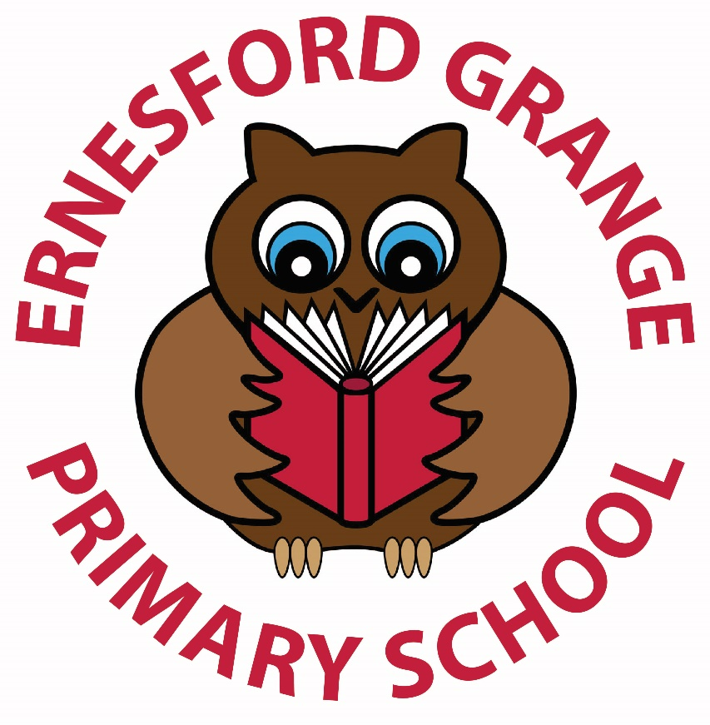

BEHAVIOUR AND

ANTI-BULLYING POLICY

Written: September 2023

Review date: September 2024

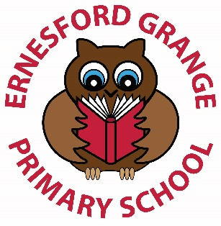
Contents

- Introduction and Ethos

- Aims

- School rules

- EYFS

- Expectations

- Rewards and Positive Strategies

- Unacceptable behaviour levels

- Lunchtime

- Persistent unacceptable behaviour

10. Use of reasonable force

Appendix A: Values and rules materials

Appendix B: Home school agreement

Appendix C: Behaviour slips

Appendix D: Primary behaviour pathway document

Appendix E: Reflection sheets

1. Introduction and Ethos
We will provide a high quality, healthy learning experience, raising the aspirations and achievements of all, and expecting the highest standards in a safe, positive environment.
We will nurture each child and support them in learning to contribute as responsible and positive members of society.
The issues of self-esteem, and of individual responsibility are at the core of the school’s work. In living out this ethos, the school has high expectations of the behaviour of staff, children, parents and governors.
We believe that:
- The quality of teaching, learning and behaviour in school are inseparable, and the responsibility of all staff.
- Poor behaviour cannot be tolerated because it obstructs the children’s rights to learn and teachers’ rights to teach.
- Respect is essential to support positive behaviour and that it must be given to be received. Parents and carers, pupils and staff all need to show mutual regard.
- Positive feedback leads to growth and improvement, but negative labelling, verbal abuse or public humiliation is damaging to an individual
- The support and involvement of parents is essential for the maintenance of good behaviour

As a school we will ensure:
- Consistent, calm adult behaviour
- We promote and recognise positive behaviour
- Relentless routines
- Scripting difficult interventions (see below)
- Restorative follow up

As part of our script and discussions with children about behaviour we have three school values/learning behaviours to refer to (the three Rs):
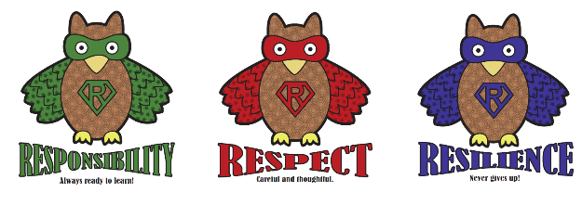
Respect Resilience Responsibility

As part of the whole school script for addressing negative behaviour, other essential language will include: right thing, right way, right place.
Each value/learning behaviour is represented by an owl. The owls will feature on display materials, postcards and reward stickers and will be referred to in assembly. Child friendly display materials will explain the definition of each of the values/learning behaviours so the children understand what behaviours are expected for rewards (see Appendix A for supporting materials).
Children will receive weekly Headteacher awards and badges for displaying these values/learning behaviours. Showing respect, resilience and responsibility will also be rewarded with postcards sent home to parents to communicate positive behaviour.
The school aims to work in partnership with home to build the self-esteem of children and encourage the growth of responsible and caring individuals. We work together to develop positive and supportive relationships that value and respect each member of our own community and the wider world. All parents are asked to sign the Home School Agreement when their child joins the school, and in so doing, to agree to support this policy.
We aim to ensure that positive behaviour is recognised and rewarded. Expectations and responsibilities are clearly shared and understood through our Golden Rules (see number 3).
Inappropriate behaviour is met with a fair and assertive response. Children are encouraged to reflect on their behaviour and future actions. All consequence are directed at the action, and not at the child. The school recognises the crucial importance of a positive climate for learning in which children can thrive. Staff are mindful of this, and of the impact of their own behaviour upon the children.

We will endeavour to ensure the school day promotes good learning and encourages positive behaviours. We understand that the following is essential; we understand that if the following is not in place it can trigger unwanted behaviour therefore:

- Curriculum will be engaging, relevant and age appropriate
- Lessons and learning in class will be differentiated
- Seating Arrangements will ensure each child has as much space as possible and pupils can move around the room with ease.
- Classrooms, resources will be well organised to create a calm and orderly atmosphere.
- Suitability of the demands and expectations on a given child. We understand that there cannot be excuses but there can be reasons for unwanted behaviour.
- The school environment is tidy, clutter free and has a calm atmosphere in shared spaces.
- There will be a range of structured lunch time clubs and activities in place for children (including identified children to participate in).
- Children will have sports equipment to play with during break and lunch time.

2. Aims

Through the operation and delivery of this policy we would aim to:
- Ensure that all children are kept safe.
- Attempt to ensure that children both remain happy in school and enjoy coming to school in order for them to attain their full potential.
- Ensure that all our actions are underpinned by a commitment to equality of opportunity.
- Ensure that everyone applies the detail of the policy consistently and fairly to all children.
- Have knowledge of this policy so that irrespective of where any member of staff is mainly based, they are able to apply the appropriate aspects of the policy in an age-related manner.
- Communicate the policy to as wide a relevant audience as is possible, e.g. parents, other staff who come into the school, including supply teachers.
- Ensure that we work from a belief in the positive aspects of discipline and behaviour, taking every opportunity to reinforce good role models within the group, class or the wider school community.
- Ensure that we as staff members set an example that the children can be proud of, can respect and can follow, so encouraging mutual respect.
- Explain the reasons behind the various aspects of the policy to the children in age appropriate ways in order that the children themselves may become more independent in their approach towards behaviour in school and have a clear knowledge of what is expected.
- To establish firm but fair discipline in both the classroom and in the school.
3. School rules:

Ernesford Grange Primary School Golden Rules:
Please remember our four Golden Rules
- We will show good manners, being kind and considerate to others at all times.

- We will treat everyone and everything with respect.

- We will listen to and follow instructions from all adults at school.

- We will walk around school safely and sensibly.

Right thing… Right way… Right place…

4. Early Years Foundation Stage

We aim for the children to develop a growing understanding of what is right or wrong and why. Explaining boundaries and limits helps them to understand why our rules exist and to feel secure within the setting. During their time in the EYFS the children will develop their learning about the impact of their words and actions both on themselves and others around them. Once they are clear what is expected of them they can move on to develop their own learning without any fears.
Nursery and Reception Staff will use a well communicated praise system for behaviour as and when the majority of the pupils are ready for this.

Rules for EYFS

- Stop, Look and Listen.
- Always be kind.
- Always help to tidy up.
- Move around the classroom carefully and safely.

There is a separate guide for unacceptable behaviour in EYFS but the levels of behaviour will follow the same 4 levels as in key stage 1 and key stage 2:

Level One  Throwing things.  Hiding. | Level Two  Damaging school property.  Being unkind.  Any Persistence of level one. | Level Three  Refusing to do what has been asked. Saying ‘no’ to adults instructions.  Any persistence of level two. | Level Four  Hurting other children  Trying to hurt adults.  Any persistence of level three.

When these behaviours occur in EYFS five key steps will be followed:

- Reminders from adults in the class about the agreed expectations of behaviour.
- A last chance reminder, ensuring the children understand what that means to have a last chance.
- Thinking time. Sitting with a sand timer (length of thinking time will be age appropriate).
- If inappropriate behaviour persists, children will be sent to an alternative setting such as a different classroom.
- If inappropriate behaviour persists after these measures, the phase leader will be notified and the situation will be dealt with accordingly, including parental contact. If necessary, the SLT or SENCO will be involved in putting measures in place to ensure behaviour improves.

5. Expectations

Classroom and areas around school will display the golden rules and the school values. It is clear that expectations for behaviour and relationships need to be shared and understood by all members of the community. As a result, the school sets out its expectations in the home school agreement (appendix B).

6. Rewards and Positive Strategies
Friday Skills Academy

All children are entitled to fifty minutes of skills academy clubs each week if they have followed the golden rules. During skills academy clubs, children will have the opportunity to take part in a range of activities of their choice.

Skills Academy is a fantastic way to have fun and learn new skills through attending clubs on a Friday afternoon.

At each club that you go to you will learn new skills and develop old ones. All these skills fit into 3 areas:

- Creative
- Physical
- Academic

Social skills and emotional well-being will underpin all of skills academy clubs.

The privilege of skills academy clubs will be withdrawn for unacceptable behaviour.
If any child loses of their skills academy club more than three times in a half term the class teacher will contact parents to inform them of their child’s behaviour.

Consequences of level 1 – 4 behaviour
Level 1: 10 minutes
Level 2: 20 minutes
Level 3 and 4: loss of all skills academy clubs

7. Guide to levels of unacceptable behaviour:

Level One: behaviour that can be effectively managed within a classroom environment by the class teacher.
Level Two: more serious negative behaviour that is not so easily managed within a classroom environment.
Level Three: Serious negative unacceptable behaviour or persistent level two type behaviour.
Level Four: Very serious unacceptable behaviour or persistent level three type behaviour.
Please see Appendix C for behaviour level slips.

Unacceptable behaviour explained:

Level One  Not on task/wasting time.  Deliberate avoidance or non-completion of set work  Distracting another child, chatting in class/assembly.  Running indoors.  Calling out or interrupting.  Negative body language and negative tone of voice. | Level Two  Any Persistence of level one.  Teasing, name calling and making derogatory comments.  Play fighting, dangerous or rough/aggressive play on the playground (including when playing football).  Retaliation.  Treating school equipment disrespectfully (including school books and play equipment).  Telling lies. | Level Three  Any persistence of level two.  Not responding to instructions; uncooperative behaviour.  Stealing.  Deliberate, persistent or malicious lying.  Inappropriate/bad language.  Deliberately damaging school or another child’s property.  Threatening behaviour towards other children.  Fighting or deliberately injuring another child.  Answering back.  Abuse on social media.  *Racial or prejudice abuse. | Level Four  Any persistence of level three.  Serious acts of sustained violence towards pupils and adults e.g. hitting, kicking, fighting, and biting.  Threatening behaviour towards other children and adults.  Persistent bad language and verbal abuse.  Refusal of an adult’s reasonable request.  Bringing dangerous items into school.  Leaving school premises without consent.  *Bullying (including bullying on social media).

*This will be investigated by the AHT/DHT or HT and could result in level 4 consequences depending on the outcomes.
*Children’s use of social media outside of school is the responsibility of parents. However, if children persistently abuse or bully other children on social media, if their actions impact on children at school or if abuse or bullying on social media brings issues into school, we will issue L3 or L4 behaviour slips if deemed appropriate by the headteacher.
All persistent level two and level three and four type behaviour will result in a full investigation and will be logged on CPOMS (please also refer to the school anti-bullying policy).

Consequences for Unacceptable Behaviour

Level 1 type behaviour

Each class teacher will use their own strategies with regards to warnings and how the class is managed.

Every lesson counts for learning and it is extremely important that lessons are not interrupted by children displaying persisting low-level behaviour.

Any child displaying level one behaviour will receive a warning. If level one behaviour continues after warnings, children will receive a behaviour slip and lose one break time and 10 minutes of their Skills Academy Club on Friday afternoon.

Teachers may also use professional judgement when deciding how much skills academy time the child should lose depending on their behaviour during the rest of the week.
*Persistence of Level One

This must be recorded in the behaviour folder. If children’s names are recorded five times or more in the behaviour folder for level 1 behaviour in a half term, a member of SMT will contact parents to alert them and to discuss the child’s behaviour.

If they then choose to display the same negative behaviour or another act of unacceptable behaviour within the lesson, they will be asked to leave the classroom for the rest of the lesson and work in a different area of school. Ideally, they will be sent to the partner class, but this may not always be possible. They will not receive any attention other than to be told where to sit. They will return to their class teacher at the end of the lesson and will then be given a level two. They will complete any work missed during their missed playtimes.
The child should then return to the next lesson and with a fresh start and approach. The same procedure will be followed. If all skills academy time has been lost for that week then the minutes lost will be calculated and the child will miss the total number of minutes in their own time: e.g.: playtimes, in addition to what they are already missing.

If the child chooses to behave inappropriately in a third lesson on the same day, then the procedure will be followed and if they are asked to leave the classroom they will be sent to the AHT/DHT. They will not return to the class for the remainder of the day.

Level 2

The child will be sent to the designated area at playtime with a yellow behaviour slip, which will refer to the reason. The level will be recorded on the class list along with the date. The slip will then be filed behind the class list.

The child will miss two of their playtimes and twenty minutes of skills academy will be lost for that week.

If any child receives a level 2 behaviour slip three times per half term a member of SLT will contact parents and inform them about their child’s behaviour (leaders and managers will monitor file on a weekly basis). Files will be kept in the head’s office.

Level 3

If a member of staff believes the child has shown unacceptable behaviour at level 3 they will summarise the incident to the DHT/AHT. The DHT will consider the behaviour and if the behaviour is a level 3 the child will be given an orange behaviour slip and sent to the designated area at playtime. The level will be recorded on the class list along with the date. The slip will then be filed behind the class list.

The child will not be allowed outside to play for the following 3 playtimes/lunchtimes and will not be allowed to take part in off-site or extra-curricular activities for the next three sessions. Lunch will be eaten whilst being supervised by AHT/DHT.

Privileges for an extended period will be withdrawn at the discretion of the Headteacher

The AHT/DHT will contact the parents that day and inform the parent/carer about their child’s behaviour.

Children will also automatically lose their skills academy club for that week.

Level 4

If a member of staff believes the child has shown unacceptable behaviour at level 4 they will summarise the incident to the HT. The HT will consider the behaviour and if the behaviour is at level 4 the child will be given a Red behaviour slip.

After investigation; parents will be immediately informed by telephone and will be expected to support the school’s actions. This phone call may be followed by a formal letter. An appointment may be made with parents, teacher and Headteacher to discuss the child’s future behaviour.

All privileges for an extended period will be withdrawn at the discretion of the Headteacher.

Children will also automatically lose their skills academy club for that week.

The child may be issued with an internal exclusion whereby the child loses the privilege to work within their class/year group/phase.

In some cases, the child may be excluded for a fixed period, usually in the first instance of 1 to 5 days and the formal recording of that exclusion will be made.

In extreme cases the child may be permanently excluded.

Fixed term and permanent exclusion will follow guidelines set by DFE. The agreed Coventry behaviour primary pathway document will be followed and referenced if any child is at risk of exclusion (appendix E).

*Please reference the new exclusions policy for further information regarding exclusion.

8. Lunchtime

DRAs will promote the school values, encourage the children to follow the same four golden rules and reward positive behaviour using the school values postcards and stickers. DRAs deal with negative behaviour using the key word as part of the school script and inform teachers or SLT of any negative behaviour at lunchtime:

Respect Responsibility Resilience

Right thing… Right way… Right place…
Golden Rules

- We will show good manners, being kind and considerate to others at all times.

- We will treat everyone and everything with respect.

- We will listen to and follow instructions from all adults at school.

- We will walk around school safely and sensibly.

Unacceptable behaviour at lunchtime:

Any unacceptable behaviour at lunchtime will be communicated to the appropriate member of teaching staff in line with the levels of behaviour guidance.
All DRAs will undertake the same training around behaviour and the behaviour policy as the rest of the school staff.
Children who struggle to behave appropriately during lunchtime will regularly be involved in a range of structured activities with sports coaches, SLT and learning mentors.

9. Persistent unacceptable behaviour (including pupils in Nursery or Reception)

On the rare occasions when a child persistently struggles or chooses not to follow golden rules and not learn from consequences (predominantly level 3 and 4 behaviours), other strategies may be put in place to support the child and to ensure teaching and learning in class is undisrupted for other pupils and staff. The school may request specialist advice and support from outside agencies. The school may consider use of a reduced timetable if deemed appropriate. The school may introduce an age appropriate daily chart to:
- split the day for the child into smaller sections.
- help the child manage their own behaviour.
- reduce the number of level consequences.
- be used to help track and log behaviours- identify patterns etc.
- to try to increase the amount of skills academy club time and build in other rewards.
- to enable regular contact with parents/carers.
The chart will be explained to the child and parents involved. Parents will be expected to return the chart daily. Should a child’s behaviour be a risk to his or her own safety and, or, that of others a risk assessment will be completed and there will be an agreed response developed between parents and school.

If a child is a placed on a chart or has similar intervention for persistent unacceptable behaviour the Headteacher may withdraw access for a period to extra-curricular activities e.g.: clubs and owls (before and after school club). The Headteacher may also restrict access to other special events such as trips and events e.g. Disco or activities off site. If there is no improvement in behaviour then the child remains on his level of intervention and monitoring, it will be the decision of Headteacher to withdraw such strategies.

Deliberate physical abuse towards other pupils and staff will not be tolerated and may result in reduced time/sessions during school, fixed term exclusions or at worst, permanent exclusion.

If the child receives many levels for unwanted behaviours on the playground then the use of a supervised play area within school could be utilised. Well trained staff will supervise the free play within the area. If behaviour in the classroom is not an issue, then a chart may be used solely for play and lunchtimes.

10. Use of reasonable force

Occasionally staff may need to use reasonable force to:

- To maintain the safety of pupils and staff
- To prevent serious breaches of school discipline
- To prevent damage to property

Staff Authorised to Use Force
‘All teachers and staff the head has authorised to have control or charge of pupils automatically have the legal power to use force and lawful use of the power will provide a defence to any related criminal prosecution or other legal action.’ At Ernesford Grange this includes all teachers, teaching assistants, and admin staff. Members of staff should not put themselves at risk. An individual would not be seen to be failing in their duty of care by not using force to prevent injury, if doing so threatened their own safety. If reasonable force is necessary, then staff will ensure that there is at least a second member of staff with them where possible.
The Governing Body of Ernesford Grange has adopted DFE guidance on ‘the Use of Force to Control or Restrain Pupils’. Most of the guidance is non-statutory, though staff are strongly advised to follow all sections of the guidance, but the section on ‘recording and reporting significant incidents’ is statutory.
Temporary authorisation can also be granted in specified circumstances such as volunteer parents helping on a school trip but this is under specific direction of a supervising member of staff.
If a child requires regular positive handling to keep themselves and others safe the headteacher will train staff in de-escalation and positive handling to ensure safe handling is used. Parents will be informed if such techniques are used. School will look to organise an agreed response document will be shared with parents and signed should regular handling be required.
Minimising the Need to Use Force
Use of force is only used as a last resort and procedures are in place at Ernesford Grange Primary School to create a calm and orderly environment and supportive school climate that lessens the risk and threat of violence of any kind. Effective relationships are developed between staff and pupils and citizenship activities support pupils in managing conflict and coping with feelings. Staff are also given guidance and training in how to manage pupil behaviour.
For more DfE guidance refer to:
https://www.gov.uk/government/uploads/system/uploads/attachment_data/file/444051/Use_of_reasonable_force_advice_Reviewed_July_2015.pdf

Sexual Abuse and Harassment

Please refer to the Child Protection policy for information regarding sexual abuse and harassment.

ANTI-BULLYING POLICY

Anti-Bullying Policy

Bullying is behaviour by an individual or group, repeated over time, that intentionally hurts another individual or group either physically or emotionally.

At Ernesford Grange we do not tolerate bullying of any kind. Every child has the right to learn in a safe and happy environment where all children respect each other as individuals.

Bullying can take many forms, it may happen face to face or indirectly through cyber bullying, all types of bullying will be taken equally seriously and will be dealt with appropriately. No child at Ernesford Grange Primary should be in fear of bullying. We understand that friends have disagreements and fall out, this is not usually bullying. The 4 main types of bullying are:

Physical hitting, kicking, taking belongings

Emotional spreading rumours, intentionally being unfriendly or excluding

Verbal name calling, teasing, insulting child or family

Cyber mobile phone calls, texts, use of social media to intimidate, insult or upset

Bullying can be motivated by actual differences or perceived differences between children. It may be due to a prejudice against a specific group. Specific types of bullying include:

- Bullying related to race, colour, religion, culture or belief
- Bullying related to special educational need or disability
- Bullying related to appearance or health condition
- Bullying related to sexual orientation
- Bullying related to home or family circumstances, different family make ups e.g. Looked after/adopted children, children from lesbian, gay, bisexual or transgender families.

Our aim is to have no bullying at Ernesford Grange, but any reported cases of bullying will be dealt with swiftly to ensure the best care and education for the children at school.

Preventing Bullying
All children are taught to treat one another and school staff with respect. The curriculum, assemblies and specific PSHCE lessons teach children to understand themselves as individuals and celebrate the differences in the school community. Class discussions, stories and the curriculum provide opportunities for children to openly discuss differences between people that could motivate bullying, such as religion, ethnicity, disability, gender or sexuality. Children are taught that the use of any prejudice-based language is unacceptable. The school’s behaviour policy ensures children take responsibility for their own behaviour and learn to understand how their actions can affect others.

Children are specifically taught about what bullying is and the forms it can take. They understand how they can prevent bullying and what to do if they are ever the victim of, or witness to, any incidences of bullying.

We use national initiatives such as anti-bullying week and external agencies to further embed the work in school that bullying, of any form, is unacceptable.

Identifying Bullying
A child may indicate by signs or behaviour that he or she is being bullied. All adults should be aware of these possible signs and investigate if a child:
- is frightened of walking to or from school/ begs to be driven to school
- changes their usual routine
- is unwilling to go to school (school phobic) and begins to truant
- becomes withdrawn anxious, or lacking in confidence
- starts stammering
- cries themselves to sleep at night or has nightmares
- feels ill in the morning
- begins to do poorly in school work
- comes home with clothes torn or books damaged
- has possessions which are damaged or " go missing"
- has dinner or other monies continually "lost"
- has unexplained cuts or bruises
- comes home hungry (lunch has been stolen)
- becomes aggressive, disruptive or unreasonable
- is bullying other children or siblings
- stops eating
- is frightened to say what's wrong
- is afraid to use the internet

Reporting Bullying
All children and families should feel confident to report bullying without fear that further bullying will take place. Bullying can be reported to:
- Any adult in school that the child/ parent/ carer feels confident to tell- teacher, senior leader, learning mentor, lunchtime supervisor.
- Another child
- A child can write a note and put it in their year group talk box located in every classroom

Dealing with bullying
Every case of bullying is a level 4 behaviour and will be logged and investigated by the Headteacher or Deputy Headteacher. Each case is individual and will be dealt with sensitively and swiftly. This may include talking with the victim and bully/ bullies, talking with other children who may have witnessed/ heard about incidents and parents will always be contacted.

Supporting children
Bullied children will always be given support, staff will reassure children that they are safe and the bullying must not continue.

Bullies must also be given support to ensure their attitude and behaviour can be improved for the future. However, consequences will also be put in place in response to the behaviour, these may include:
- Writing a letter of apology
- Missed playtimes
- Loss of extra-curricular activities and privileges
- In serious cases, exclusion may be considered

Resolving Bullying
All the children involved should be part of the discussions leading to a positive solution. Honest group discussions with a supportive adult should aim to resolve the situation and identify a positive way forward. Staff should ensure that they follow up any actions put in place and are vigilant to ensure no further bullying takes place.

Involving Parents/ Carers
- Parents/ Carers will be informed of policy and procedures for preventing, reporting and dealing with bullying.
- Parent workshops on cyber bullying and e-safety.

Logging and Monitoring cases of bullying
Staff may setup weekly meetings with a child who they feel is vulnerable or who feels they are being bullied. This would ensure there is a weekly conversation to share any concerns. There may be observations of children in the playground. A diary may also be introduced where the child is encouraged to write down any issues that they feel they cannot talk about.
An annual questionnaire to children and families is used to inform school practice and regular pupil and parent conversations identify any areas of potential concern and future actions.

