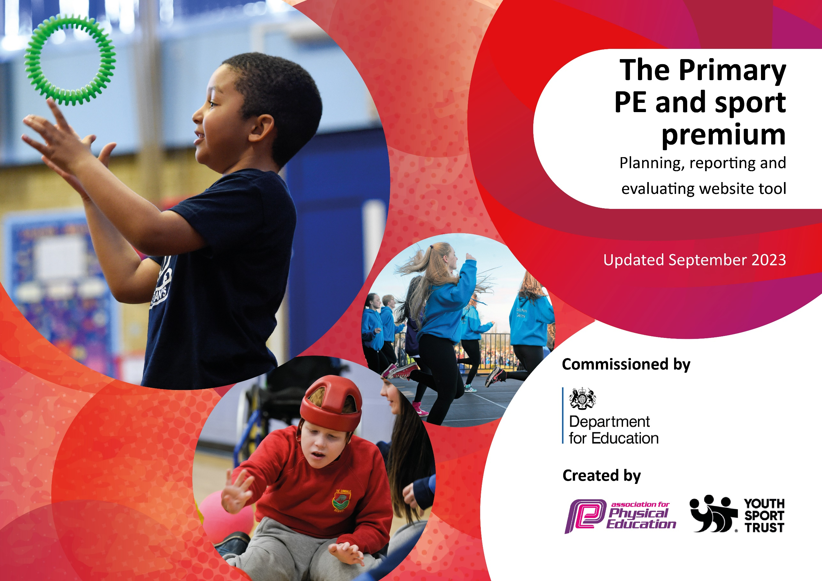

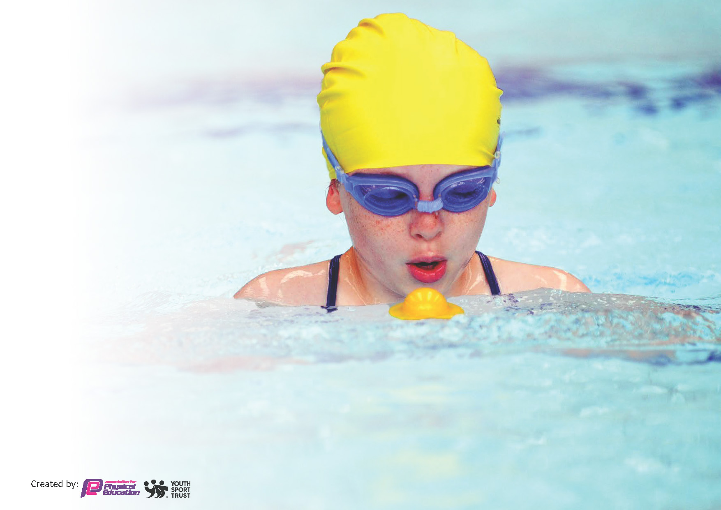
This template can be used for multiple purposes:
by:
- It enables schools to effectively plan their use of the Primary PE and sport premium
- It helps schools to meet the requirements (as set out in guidance) to publish information on their Primary PE and sport premium
- It will be an effective document to support Ofsted inspections enabling schools to evidence progress in Physical Education (PE) and evidence swimming attainment, which forms part of the PE National Curriculum. We would recommend schools consider
the Intent, Implementation and Impact of any spend, as examined within the Education Inspection Framework.

It is important that your grant is used effectively and based on school need.

Schools must use the funding to make additional and sustainable
improvements to the quality of the PE, School Sport and Physical Activity (PESSPA)
they offer. This means that you should use the Primary PE and sport premium to:

- Build capacity and capability within the school to ensure that improvements made now will benefit pupils joining the school in future years
- Develop or add to the PESSPA activities that your school already offers.

The Primary PE and sport premium should not be used to fund capital spend projects; the school’s core budget should fund these. Further detail on capital expenditure can be found in the updated Primary PE and sport premium guidance.

The Primary PE and sport premium guidance, outlines 5 key priorities that funding should be used towards. It is not

necessary that spending has to meet all the key priorities, you should select the priorities that you aim to use any funding towards.

Although completing this template is not a requirement for schools, schools are required to publish details of how they spend this funding. Schools must also outline what the impact this funding has had on pupils’ PE and sport participation and attainment and how any spending will be sustainable in the future. All funding must be spent by 31st July 2024.

The Department for Education has worked closely with the Association for Physical Education (afPE) and the Youth Sport Trust (YST) to develop this template and encourages schools to use it. This template is an effective way of meeting the reporting requirements of the Primary PE and sport premium.
Review of last year’s spend and key achievements (2022/2023)

We recommend you start by reflecting on the impact of current provision and reviewing your previous spend.

Activity/Action | Impact | Comments
Lunchtime clubs run by sports coach.  Swimming Y6  Transport to events | 72% children attended at least one club for half a term.  All three criteria met by over 65% of children.  52% children took part in competitive events. | Review data half termly to monitor % taking part.

Key priorities and Planning
This planning template will allow schools to accurately plan their spending.

Action – what are you planning to do | Who does this action impact? | Key indicator to meet | Impacts and how sustainability will be achieved? | Cost linked to the action
Increase participation in netball and start a school netball team. | Subject lead. Year 5 and 6 children. | KI 2 and 4 | More pupils meeting their daily physical activity goal, more pupils encouraged to take part in PE and Sport Activities. | £500
Get Set 4 PE | Teachers, sport coaches and children. | KI3 | Planning and assessment for core PE lessons. | £560
Outdoor classroom | Children from Rec-Y6. Teachers and sport coaches. | KI 1 and 2 | Children able to have active lessons in all weathers. | £5000
Sport coaches | Children from Y1-Y6. | KI 2 and 4 | Offer a broader array of sports during skills academy. | £1000
Transport to events | Children Y2-Y6 | KI 5 | Increase participation in competitive sports. | £1500
Lunchtime clubs run by sports coaches | Rec-Y6. | KI 1 | Provide chn with opportunities to be active during the school day. | £4000
Outdoor classroom games | Rec-Y6 | KI 1 and 2 | Encourage children to be active during free time. | £500
Balance Bikes | Rec-Y2 | KI1 and 4 | Improve co-ordination and balance and provide chn with another physical activity. | £1500
Training Deep Dive in PE | PE Lead | KI3 | Knowledge gained by PE lead to implement in school. | £200
Training PE Conference | PE Lead | KI3 | Knowledge gained by PE lead to implement in school. | £100
Swimming | Y5 | KI1 and 4 | Top-up swimming | £950
Playtime equipment | Rec-Y6 | KI1, 4 and 5 | All children have access to play equipment at break and lunchtimes. | £1500
Real PE | Rec-Y6 | KI3 | Planning and assessment | £1695
Sainsburys Games participation | Y1-Y6 | KI1, 2, 3, 4 and 5 | Knowledge sharing, competitive games, various sports | £450

Key achievements 2023-2024
This template will be completed at the end of the academic year and will showcase the key achievements schools have made with their Primary PE and sport premium spending.

Activity/Action | Impact | Comments
Real Pe and Get Set4PE online curriculum platforms.  Outdoor classroom and resources.  Equipment and resources. | Curriculum resources support staff to deliver high quality lessons.  Outside lessons are a key feature of our curriculum. Active lessons support children’s learning, behaviour and development.  Children are active during break and lunchtimes because they have access to a variety of resources. | Platforms help to develop teacher’s and coaches subject knowledge and assessment processes.  Active learning is now embedded within our curriculum for all children.  Having a variety of resources increases children’s fitness levels but also exposes them to different sports.

Swimming Data
Meeting National Curriculum requirements for swimming and water safety.
Priority should always be given to ensuring that pupils can perform safe self-rescue even if they do not fully meet the first two requirements of the National Curriculum programme of study

Question | Stats: | Further context  Relative to local challenges
What percentage of your current Year 6 cohort can swim competently, confidently and proficiently over a distance of at least 25 metres? | 66% | X2 week intensive course offered.
What percentage of your current Year 6 cohort can use a range of strokes effectively [for example, front crawl, backstroke, and breaststroke]? | 64% | X2 week intensive course offered.

What percentage of your current Year 6 cohort are able to perform safe self-rescue in different water-based situations? | 72% | X2 week intensive course offered.
If your schools swimming data is below national expectation, you can choose to use the Primary PE and sport premium to provide additional top-up sessions for those pupils that did not meet National Curriculum  requirements after the completion of core lessons. Have you done this? | Yes
Have you provided CPD to improve the knowledge and confidence of staff to be able to teach swimming and water safety? | Yes  Staff attending swimming lessons raise awareness of the x3 criteria.

Signed off by:

Head Teacher: | Ian Taylor
Subject Leader or the individual responsible for the Primary PE and sport premium: | Carly Appleton Assistant Headteacher
Governor: | Claire Saunders
Date: | July 2024

