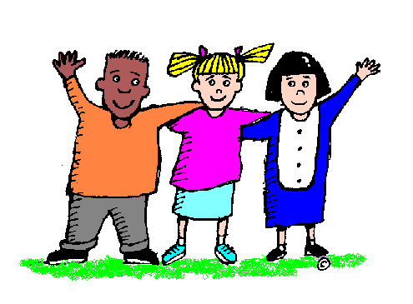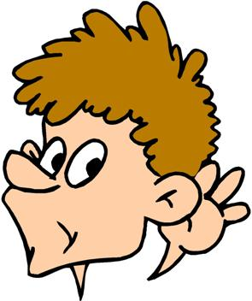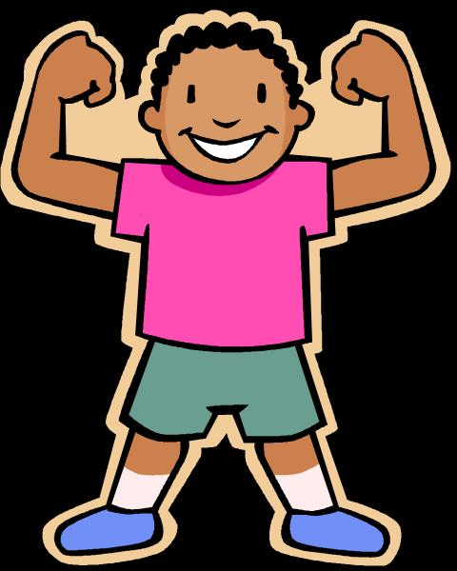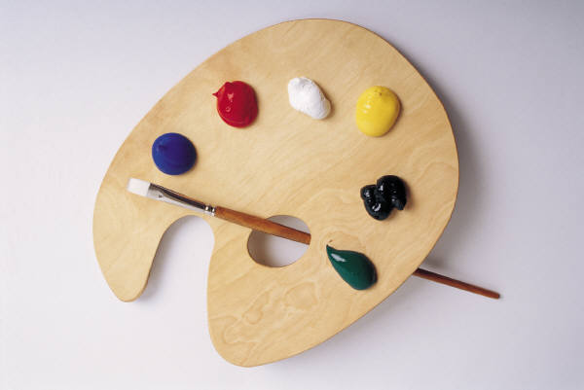

**Other Areas of Learning**

We have talked about being a good friend and what that means.

We have thought about how we can be kind and caring to each other, help each other when we are hurt or sad, play together by sharing and taking turns,

– being friendly!

Everyone has finished a self-portrait, taken a selfie and written their name for a “Do You Want To Be Friends?” display in the classroom. For the portrait, children had to look closely at their image in a mirror and try to match what they could see, particularly thinking about their use of colour.

The children are really enjoying their P.E. lessons with Mr. Burgess, learning and practising lots of different physical skills.

**This week we have been thinking about what makes a good friend.**

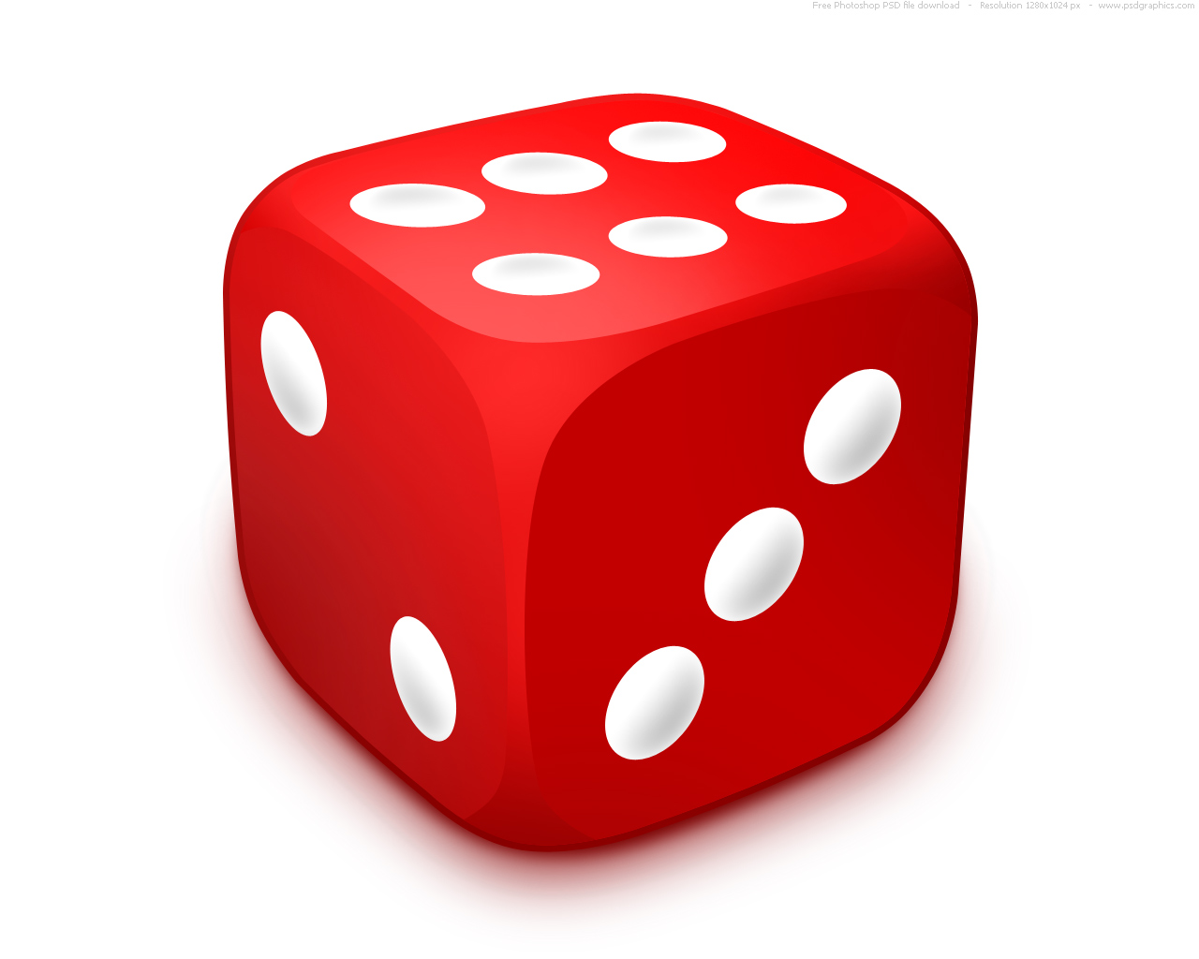**Mathematics**

This week’s learning has been about measuring and comparing the sizes of different things, including ourselves!

With a partner they found out who had the larger hand, the longer leg, who was taller etc.

We have also measured children with string!

Description: C:\Users\taylorj\AppData\Local\Microsoft\Windows\Temporary Internet Files\Content.IE5\HA3BLP6I\MC900232054[1].wmf**Literacy**Description: C:\Users\taylorj\AppData\Local\Microsoft\Windows\Temporary Internet Files\Content.IE5\HA3BLP6I\MC900232054[1].wmf

We have had lots of fun with Phonics this week! We have been working on the first set of sounds in Phase 2 phonics, concentrating on hearing the initial sounds in words, blending sounds into words and practising writing s/a/t/p with correct letter formation.

**This week in Reception**

**September 27th – October 1st 2021**