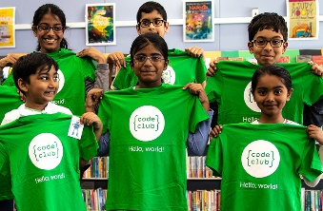
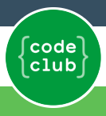
1st March 2020

Dear Parents,
We are offering Key Stage 2 children the opportunity to take part in an after school Code Club. This will be a free of charge session, running for 6 weeks every Monday 3:30-4:30.
There are 15 places available. If your child would like to attend, please could you register your interest using the reply slip below and return to Mrs Taylor (Year 3) as soon as possible.
What do young people learn at Code Club?
At the club sessions, young people follow the project guides specially created by us. Club organisers provide support to help young people progress through our projects, to create games, animations, and web pages using Scratch, Python, or HTML/CSS.
What is coding?
Coding is giving instructions to a computer to tell it to do things. Learning to code is a bit like learning a second language, because to give instructions to a computer, you need to put the instructions into a language the computer understands.
Regards,
Mrs J Taylor
Computing Coordinator

I give my consent for my child ____________________________ Class _______________
to attend the after-school Code Club running between 3:30 – 4:30.

Signed ______________________________________ Date_______________________________

