# E:\Users\simon.roche\AppData\Local\Microsoft\Windows\Temporary Internet Files\Content.Word\Evidencing the Impact of the Primary PE and Sport Premium Template 2019 7.3 Images_Page_1.jpg

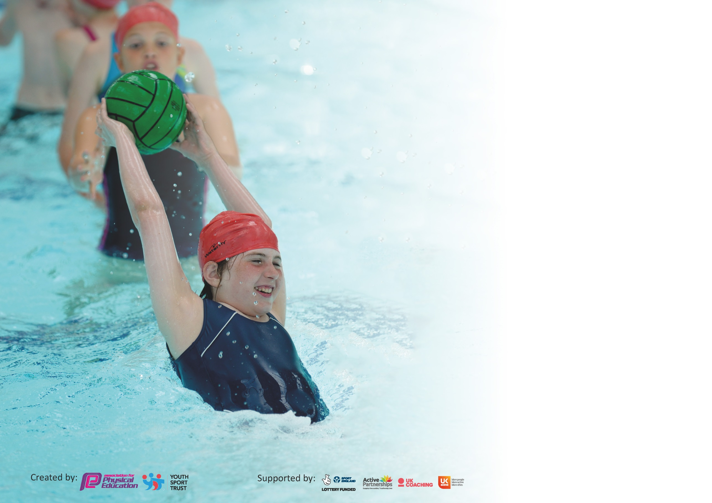

It is important that your grant is used effectively and based on school need. The [Education Inspection Framework](https://assets.publishing.service.gov.uk/government/uploads/system/uploads/attachment_data/file/843108/School_inspection_handbook_-_section_5.pdf) (Ofsted 2019 p64) makes clear there will be a focus on **‘whether leaders and those responsible for governors all understand their respective roles and perform these in a way that enhances the effectiveness of the school’**.

Under the [Quality of Education criteria](https://assets.publishing.service.gov.uk/government/uploads/system/uploads/attachment_data/file/843108/School_inspection_handbook_-_section_5.pdf) (p41) inspectors consider the extent to which schools can articulate their curriculum (INTENT), construct their curriculum (IMPLEMENTATION) and demonstrate the outcomes which result (IMPACT).

To assist schools with common transferable language this template has been developed to utilise the same three headings which should make your plans easily transferable between working documents.

Schools must use the funding to make **additional and sustainable** improvements to the quality of Physical Education, School Sport and Physical Activity (PESSPA) they offer. This means that you should

use the Primary PE and Sport Premium to:

* Develop or add to the PESSPA activities that your school already offer
* Build capacity and capability within the school to ensure that improvements made now will benefit pupils joining the school in future years

Please visit [gov.uk](https://www.gov.uk/guidance/pe-and-sport-premium-for-primary-schools) for the revised DfE guidance including the 5 key indicators across which schools should demonstrate an improvement. This document will help you to review your provision and to report your spend. DfE encourages schools to use this template as an effective way of meeting the reporting requirements of the Primary PE and Sport Premium.

We recommend you start by reflecting on the impact of current provision and reviewing the previous spend.

Schools are required to [publish details](https://www.gov.uk/guidance/what-maintained-schools-must-publish-online#pe-and-sport-premium-for-primary-schools) of how they spend this funding as well as on the impact it has on pupils’ PE and sport participation and attainment by the end of the summer term or by **31st July 2020** at the latest.

We recommend regularly updating the table and publishing it on your website throughout the year. This evidences your ongoing self-evaluation of how you are using the funding to secure maximum, sustainable impact. Final copy must be posted on your website by the end of the academic year and no later than the 31st July 2020. To see an example of how to complete the table please click [HERE](http://www.afpe.org.uk/physical-education/wp-content/uploads/afPE-Example-Template-Indicator-2018-Final.pdf).

Support for review and reflection - considering the 5 key indicators from DfE, what development needs are a priority for your setting and your pupils now and why? Use the space below to reflect on previous spend and key achievements and areas for development.

|  |  |
| --- | --- |
| Key achievements to date until July 2019: | Areas for further improvement and baseline evidence of need: |
| * 55% of pupils engage in at least 2 extra-curricular activities per week. * 34% of pupils engage in art least 1 extra-curricular club across the year. * Only 11% of children have not engaged in an extra-curricular activity at school outside of their 2 hours PE allocation. * 100% of pupils engage in personal challenge activities led in team colours. * 76% of pupils in year 6 have represented the school in a sporting event. * 100% in-school competitions * 51% of pupils engage in Sainsburys School Games * 29% of pupils engage in Coventry School Association competitions | To improve the subject knowledge of PE lead and sports coach in delivering and supporting staff with the new Real PE curriculum. This tool has many different elements which we aim to use to its full potential. Teachers and teaching assistant’s confidence and knowledge on delivering the new PE scheme, Real PE.  Playground leaders to support more in daily activities during break time. Evidence that children are more like to engage in active play when there is an organised activity led by either a member of staff or older children. Leaders will require more training and support in managing larger groups/space which Real PE ‘Playleaders’ scheme can support with.  Active lessons, especially in maths, to be a weekly occurrence across the school.  Children to be exposed to a wider variety of sport clubs during break/lunch and skills academy time to encourage them to find a love of fitness which suits them best. |

|  |  |
| --- | --- |
| Meeting national curriculum requirements for swimming and water safety. |  |
| What percentage of your current Year 6 cohort swim competently, confidently and proficiently over a distance of at least 25 metres?  **N.B.** Even though your pupils may swim in another year please report on their attainment on leaving  primary school at the end of the summer term 2020. | 63%  Y4 data |
| What percentage of your current Year 6 cohort use a range of strokes effectively [for example, front crawl, backstroke and breaststroke]? | 58%  Y4 data |
| What percentage of your current Year 6 cohort perform safe self-rescue in different water-based situations? | 52%  Y4 data |
| Schools can choose to use the Primary PE and Sport Premium to provide additional provision for swimming but this must be for activity **over and above** the national curriculum requirements. Have you used it in this way? | No, due to Covid-19 our Year 6 cohort did not have their top up swimming sessions. |

**Action Plan and Budget Tracking**

Capture your intended annual spend against the 5 key indicators. Clarify the success criteria and evidence of impact that you intend to measure to evaluate for pupils today and for the future.

|  |  |  |  |  |
| --- | --- | --- | --- | --- |
| **Academic Year:** 2019/20 | **Total fund allocated: £19,720** | **Date Updated: July 2020** | |  |
| **Key indicator 1:** The engagement of all pupils in regular physical activity – Chief Medical Officer guidelines recommend that primary school pupils undertake at least 30 minutes of physical activity a day in school | | | | Percentage of total allocation: |
| 45% |
| **Intent** | **Implementation** | | **Impact** |  |
| Your school focus should be clear what you want the pupils to know and be able to do and about  what they need to learn and to  consolidate through practice: | Make sure your actions to achieve are linked to your intentions: | Funding allocated: | Evidence of impact: what do pupils now know and what can they now do? What has changed?: | Sustainability and suggested next steps: |
| Active teaching and learning:  Develop approach to support active TLA strategies in classrooms across school.  Ensure 1x lesson per week minimum is an Active Maths lesson by the end of the summer term.  Active Mile  Break/lunchtime/skills academy extra opportunities  Play leaders  Training and leadership opportunities for year 6 pupils.  Support activities during lunch/break times.  Focus on children with SEND/physical disabilities. | Purchase Teach Active Maths.  All KS2 classes to be using at least one active maths lesson per fortnight – Autumn Term. Reviewed by PE lead and Maths co-ordinator,  X2 active maths lessons every fortnight – Spring and Summer Term. PE Subject Lead and Maths co-ordinator reviewed delivery and impact.  KS1 and KS2 walking/running the active mile during their afternoon session 3x per week at least.  Sports coach lunchtime provision Rower – available at break/lunchtimes on a year group rota basis for a time limit of 1 minute per child. Used consistently for 15 minutes as break and 30 minutes at lunchtime.  Fitbits, class set. Allow the children to take responsibility for their fitness levels. Used during skills academy running club and cross country running club to set targets and Y6 science lessons to measure heartrate.  PE subject lead and PE coach training session with children beginning of each term.  Equipment purchase/kit purchase for play leaders.  Focus on children in year 3 and 4 who previously hadn’t attended any extra-curricular clubs.  Play leaders work on a rota basis and keep a register of children attending and activities covered.  Focused interventions – children with additional physical needs. Children identified as below ARE in PE supported with basic skills focus. Physiotherapy targets. | £645  £200 cover support  £200 cover support  £4300  £715  £230  £300 for cover  £330  Cover for PE coach for the year £1800 | 251 KS2 children taking part in at least one active maths lesson a week on average. (Some maths strands are more compatible than others). (2018-19 Active lessons were sporadic approx. x10 per year for each KS2 class).  KS1 and EYFS were already delivering more active lessons but this scheme has supported a more focused approach.  100% of children stated they enjoy active maths lessons with 89% reporting that they find maths ‘more fun’ during these lessons. Teacher review was also very positive especially in response to level of engagement of children with additional needs in maths. 98% reported high levels of engagement.  100% children experienced the active mile.  All teachers report children are more focused after their afternoon mile.  90.2% children in KS2 are involved in an extra-curricular club outside of their 2 hour PE allocation including active play at breaktimes.  Before school running club – 23 children.  Skills Academy running club – Autumn 1 – 39 children KS2  Spring 1 – 35 children KS2  Summer - Covid-19  82% taking part in 15 minutes breaktime activities and 25 minutes lunchtime activities daily.  Trend – 95% behaviour slips given at lunchtime when children aren’t involved in play lead activity.  14 children, session once a week with PE lead and sports leaders.  10 of the 14 children then attended sessions on other days.  6/10 children then took part in activities offered at break/lunchtimes/sporting skills academy club as their confidence grew. | Practice to be embedded in maths curriculum.  Continue to review impact on progress once new White Rose maths scheme has been established.  SLT to observe and monitor use of active lessons to support whole school development in maths and active learning.  Continue to offer extra-curricular activities at lunchtime. Sports coach to contribute to training sports leaders. PE lead to explore skills amongst current staff to offer more clubs to children within the school day. Especially those children who do not stay for after school clubs.  Current year 5 children will need training to take over the role of sports leaders. Real PE Scheme offer guidance and a structured programme which we will introduce during the Autumn Term.  Continue to track those children not attending any extra-curricular clubs and target them during break/lunchtimes.  Use Real PE section play leaders to further develop this role.  Sports coach to work with TAs to support in delivery of specific physical targets. |
| **Key indicator 2:** The profile of PESSPA being raised across the school as a tool for whole school improvement | | | | Percentage of total allocation: |
| 35% |
| **Intent** | **Implementation** | | **Impact** |  |
| Your school focus should be clear what you want the pupils to know and be able to do and about  what they need to learn and to  consolidate through practice: | Make sure your actions to achieve are linked to your intentions: | Funding allocated: | Evidence of impact: what do pupils now know and what can they now do? What has changed?: | Sustainability and suggested next steps: |
| New scheme of work to focus on skill progression.  Children to learn a sense of ownership and responsibility by representing their school. | Real PE purchased.  Training from Real PE Spring Term.  Introduce to all year groups from Rec-Y6 Summer 1. PE lead to observe lessons in each key stage using Real PE, Summer 2.  14xipads and cases for children to use during Real PE section of their lesson.  Competition equipment/uniform. | £495  £1795  £200 cover  £4228  £660 | Due to timing, we were unable to deliver any Real PE lessons and didn’t have the relevant training due to Covid-19.  Children felt prepared for competitions and the school reached nine level 3 competitions and five level 2s during Autumn Term and Spring 1. | Training re-organised for Autumn Term. PE Subject Lead had 1:1 zoom training during lockdown. £1795 whole school training next year.  SLT to ensure that once training is delivered, teachers and sports coach are accessing and using Real PE and using it to its full potential.  Equipment and uniform can be used again next year. Sports leaders have helped to look after equipment to ensure durability. |

|  |  |  |  |  |
| --- | --- | --- | --- | --- |
| **Key indicator 3:** Increased confidence, knowledge and skills of all staff in teaching PE and sport | | | | Percentage of total allocation: |
| 8% |
| **Intent** | **Implementation** | | **Impact** |  |
| Your school focus should be clear | Make sure your actions to | Funding | Evidence of impact: what do | Sustainability and suggested |
| what you want the pupils to know | achieve are linked to your | allocated: | pupils now know and what | next steps: |
| and be able to do and about | intentions: |  | can they now do? What has |  |
| what they need to learn and to |  |  | changed?: |  |
| consolidate through practice: |  |  |  |  |
| Coaching and training.  New scheme of work. Real PE.  Dance Curriculum – children have lessons delivered by a trained specialist in this are of PE.  Gymnastics curriculum. | Wasps Netball morning – children attended a Wasps netball morning with their netball coach/PE lead.  PE coach - basketball course.  Real PE. Teachers have a structured scheme to follow which has differentiated videos which ensure progression of skills.  CV Life dance lessons.  PE coach and teachers in Y3 and Y6 are upskilled in the delivery of dance lessons.  PE coach and teachers in Y4 and Y5 are upskilled in the delivery of gymnastics lessons. | £40 course  Cover for PE lead £80  Course - £125  Cover PE coach - £50  £495  £600  £300 | Netball clubs remained consistent in numbers from 2018-2019.  Basketball course cancelled due to Covid-19.  Not used due to cancelled training and Covid-19  Teachers report an increased in confidence and knowledge when delivery this area of the curriculum. Each teacher asked jumped a grade up in their grading of themselves in all areas: confidence, knowledge and assessment.  PE subject lead observed teachers supporting small groups within these lessons. 92% of lessons observed used team teach effectively. | Lunchtime netball club instead of after school so can include all yr 5 and 6 children.  Although teachers confidence and knowledge has increased in this area, this continues to be an area for further development next year. PE lead/coach will be expected to apply their knowledge to lessons taught independently and share good practice with other year groups. PE lead to facilitate. |
| **Key indicator 4:** Broader experience of a range of sports and activities offered to all pupils | | | | Percentage of total allocation: |
| 5% |
| **Intent** | **Implementation** | | **Impact** |  |
| Your school focus should be clear | Make sure your actions to | Funding | Evidence of impact: what do | Sustainability and suggested |
| what you want the pupils to know | achieve are linked to your | allocated: | pupils now know and what | next steps: |
| and be able to do and about | intentions: |  | can they now do? What has |  |
| what they need to learn and to |  |  | changed?: |  |
| consolidate through practice: |  |  |  |  |
| To provide new experiences to support a lifelong engagement in sports and activities:  Skills academy clubs  Extra-curricular clubs  To focus on children not attending any extra-curricular clubs (data taken from 2018-2019). Activities provided at lunchtimes, changed half termly, led by sports leaders with support from PE lead. | Boccia equipment  Ultimate frisbee equipment  American Football  Tennis membership  Irish dancing  Dance lunchtime club specialist teacher.  1x session a week at lunchtime. Club targets either year 3 and 4 or year 5 and 6 so can be age specific.  Bootcamp style, races, high intensity training, fast paced walking etc. | £115  £100  £50  £15  £660  £100 resources.  £25 per session PE coach support (£575) | 18 children KS1 and 22 KS2.  24 KS2 Children attended.  30 KS2 children attended.  28 children  30 children.  6 extra clubs were offered this academic year compared to last year.  Each session attended by over 50% of children on targeted list. | Continue to provide a variety of different clubs. Staff to explore further training so more staff can provide different activities especially during skills academy. Sporting activities are always popular and places fill up quickly.  Continue to track children next year and ensure those on list are monitored closely/encouraged to attend clubs on offer.  Children’s questionnaire – what clubs would they like? |

|  |  |  |  |  |
| --- | --- | --- | --- | --- |
| **Key indicator 5:** Increased participation in competitive sport | | | | Percentage of total allocation: |
| 7% |
| **Intent** | **Implementation** | | **Impact** |  |
| Your school focus should be clear | Make sure your actions to | Funding | Evidence of impact: what do | Sustainability and suggested |
| what you want the pupils to know | achieve are linked to your | allocated: | pupils now know and what | next steps: |
| and be able to do and about | intentions: |  | can they now do? What has |  |
| what they need to learn and to |  |  | changed?: |  |
| consolidate through practice: |  |  |  |  |
| Encourage children to take part in competitive sports both within school competitions and inter school comps.  Football and netball local competitions.  Transport to ensure all children can attend events.  Active weeks | Sainsbury’s games:  Children take part in a variety of competitions, competing against schools from across the city.  CPSSA  Travel to competitions  Week before sports day hold various intra school competitions.  Assault course – Autumn Term.  Assault course – Spring Term. Chn try to beat time from Autumn Term.  Summer:  Guest speakers.  HIIT session for parents and children on playground.  Healthy Eating/lifestyles.  Walk/ride to school prizes. | £400  £60  £550  £100 PE coach cover.  £100 PE coach cover.  PE lead plan and organise. £50 cover.  PE lead plan and resource lessons  £50  £100 | 67 children took part in inter school competitions. The summer term is our busiest so this percentage would have risen.  13% of children represented the school.  31% of children accessed transport for competitions.  Sports Day team colours celebrated giving children a sense of unity and identity with their team.  Covid-19 | Continue to participate in inter school competitions. |

|  |  |
| --- | --- |
| Signed off by | |
| Head Teacher: | Ian Taylor |
| Date: | 22.7.20 |
| Subject Leader: | Carly Appleton |
| Date: | 22.7.20 |
| Governor: | Simon Miller |
| Date: | 22.7.20 |

|  |
| --- |
| Due to Covid-19 we have an underspend of £4945. Reasons: specialist teachers, cover for PE lead/maths lead/PE coach not required. Real PE training not delivered. Active week – postponed. Top up swimming didn’t take place. Less transport required (most competitions happen in Summer term). |