Dear parent/carer,

In light of a changing national picture and an imminent national lockdown I wanted to write to you to thank you for your continued support and provide further reassurance on the position in schools across Coventry.

It is recognised locally and nationally how important it is that, despite national restrictions, our children and young people can maintain as normal a way of life as possible. We are fortunate to have wonderful schools, with excellent and dedicated
teachers and staff and we believe that all children should be in lessons, not only to learn, but also for their own mental and physical wellbeing.

We are pleased to be helping your child/children to continue with their education. I recognise there have been, and will continue to be, situations across the city where children / young people are required to self-isolate because of contact with a confirmed case in an education setting. This is obviously a necessary precaution to prevent the spread of COVID 19 and keep Education settings open to as many children and young people as possible.

Where pupils do need to self-isolate, schools will support them to continue with their education using remote learning packages and continue to build on what was in place over the Spring and Summer. I would also like to reassure you that the decision to partially close / close an education setting is never taken lightly, and is done in full consultation between the setting, the local authority and Public Health taking into account the specific local circumstances, and following Public Health England advice and government guidance.

We continue to take every measure to make sure our schools are as safe as possible, and I would like to thank you for your continued support in helping our city reduce COVID-19. Schools continue to review risks in their settings and adapt risk assessments, and as a city we share our learning across all schools to ensure we can remain open safely.

Moving into a national lockdown position, there are obviously tighter restrictions for people to adhere to and as a parent or carer there are a number of things that you can continue to do to help make our education settings safe. These are:

- Not sending your child to their nursery, childminder, school or college if they are showing coronavirus symptoms or someone within the household is showing symptoms
- Keeping your child at home where they have been identified as having contact with a confirmed case either in school or elsewhere
- Arranging a test if you or your child develops symptoms – no matter how mild – and informing the nursery, childminder, school or college of the result. Although there were previous problems with testing capacity these have now been resolved
- Ensuring that the whole household isolate where a household member is awaiting a result, and continued isolation if test result is positive
- Reinforcing with your children how to wash hands, make space and minimise contact
- Adhering to the current rules and guidance (including reinforcing with older children for travel to/from school and outside school) which will help reduce transmission
- Supporting your schools by understanding and reinforcing with your children where they are required to wear face masks both in school (in line with school policy) and on public transport (including dedicated school buses)
- Adhering to the current rules when you pick up and drop off students at school sites, and ensuring you wear a facemask, maintain a 2 metre distance from other parents (including not blocking entrances, exits, or immediate areas outside of schools)

If you would like any more help and advice around COVID-19, please go to
https://www.gov.uk/coronavirus

Yours sincerely,
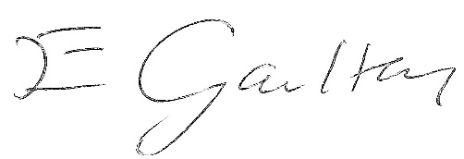
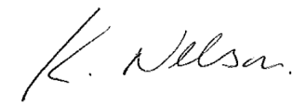

Kirston Nelson Liz Gaulton
Director of Education & Skills Director of Public Health and Wellbeing

