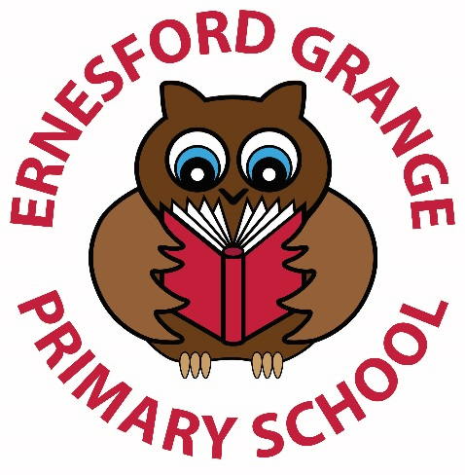

Owls Before and After School Club
Prospectus

Welcome to…
Ernesford Grange Primary School
Before and after school club – Owls
We aim to create a stimulating and happy environment for your child(ren) in which they learn and have fun. We hope parents will work in partnership with us to provide the children with the very best of care.
Organisation plan
Julia Richards – Manager EYCE3/NO4/ LM3/DSL | Carol Breslin – Early Years Practitioner | Ian Taylor – Head Teacher  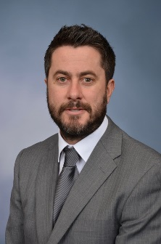  Deputy Manager
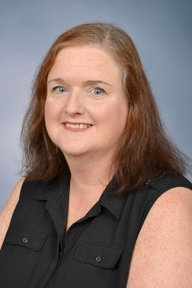  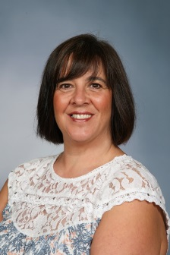  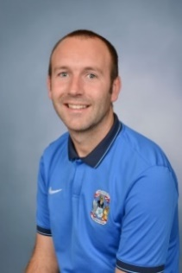  Mike Hancock – Sports Coach | Natalie Ord – Early Years Practitioner

Registration
To register for a place in Owls, parents/carers should:
- Complete a registration form, available from the school office or a member of the Owls before and after school club.
- Return the completed registration form to the staff in Owls or the school office.
Subject to availability, an offer of a place will be made and the required amount of hours booked in advance, subject to the discretion of the manager.

Payment will be required in advance. Non-payment will result in the offer of a place being withdrawn.

Late payment will result in an additional fee of £10.00. An additional fee of £10.00 per child will be charged if your child is collected after 6pm.

Scale of Charge
Morning sessions | £6.00 per child
Afternoon sessions | £8.00 per child
Late collection fee | £10 per child
Late payment fee | £10
Times
Owls club starts at 7:30am
Breakfast is served between 7:30am and 8:15am
Children are taken to their classrooms for the start of the school day.
Children will be taken to Owls by an adult at the end of the school day.
Owls closes at 5:30pm prompt.
Please do not bring children before 7:30am as there are no adults available to supervise them.
Please do not collect children any later than 6:00pm. Late comers could be subject to additional fee.

Daily Routines

Mornings
Parents/carers must accompany children into school. The gates will be locked. Therefore, the intercom positioned on the Foxton Road pedestrian gate should be used in order to gain entrance. On arrival, a member of staff will show you where to sign your child in.

The children will be supervised and offered a cold drink and a healthy breakfast. At 8:45am, the children will be escorted to their classrooms for the start of the day.

After school
A register of those children attending the club is circulated to the teaching staff. A member of staff will collect children from the classrooms and take them to Owls to be registered. During the sessions, children will be offered a healthy snack. Parents/carers arriving to collect their child(ren) from Owls will need to use the intercom on Foxton Road gates to gain entry. They will be asked to sign out their child.
Food at Owls
We are a before and after school club that provides breakfast (should your child(ren) choose to eat it). We are not a ‘Breakfast Club’. Fruit is usually available for the children to help themselves to.
Please do not send your child(ren) with their own breakfast. We will provide the breakfast food that is to be eaten in the setting. If your child wishes to eat something other than what is provided at Owls, could you please ensure that it is eaten before they arrive at Owls.
A healthy snack is provided for the children in the afternoon, along with a cold drink. Fruit is usually available for the children to help themselves to. The snack provided will not be equal to an evening meal!
All food served at Owls on a regular basis is food that is recommended by The School Food Trust. Food may vary on special occasions.
Activities
The Owls club staff will encourage the children to be involved in as many activities as possible, such as:

- Outdoor games
- Videos
- iPads
- Books
- Owls Council
- Singing
- Colouring
- ‘Activate’
- Science opportunities
- Creativity
- Welly walks
- DVDs
- Television
- Music and dance
- Electronic games
- Table-top games
- Painting
- Role play
- Writing
- Cooking
- And so much more!

It is our aim for our children to be happy and relaxed after their hard day at school. Although we plan lots of different activities for the children, we always let the children choose the activities they take part in.
Contact us
If you need to contact us at any time, please ring 024 7645 4843 or 07534 277758.
We are a very friendly team of staff who will be more than happy to assist with any enquires that you may have. You can also find information about Owls on the school website.
Other information
Please do not hesitate to ask the Owls staff for the policies of the setting should you wish to read them. A copy of relevant information will be sent out to you every September, with your renewal pack. The settings policies are reviewed annually by the whole team of Owls staff.
Currently, we offer a Summer Club during the first week or first two weeks (depending of staff availability). Letters including the exact details go out nearer the dates. Opening times for the Summer Club are 8am to 5pm daily – apart from the last Friday of the club, which has a closing time of 4:30pm.

