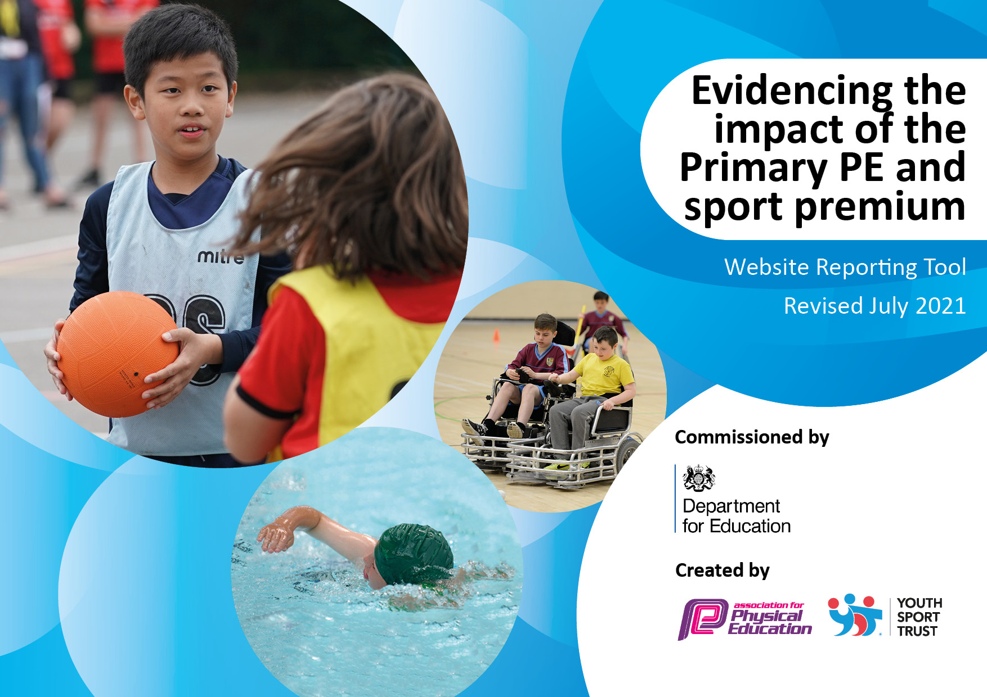
Revised July 2022
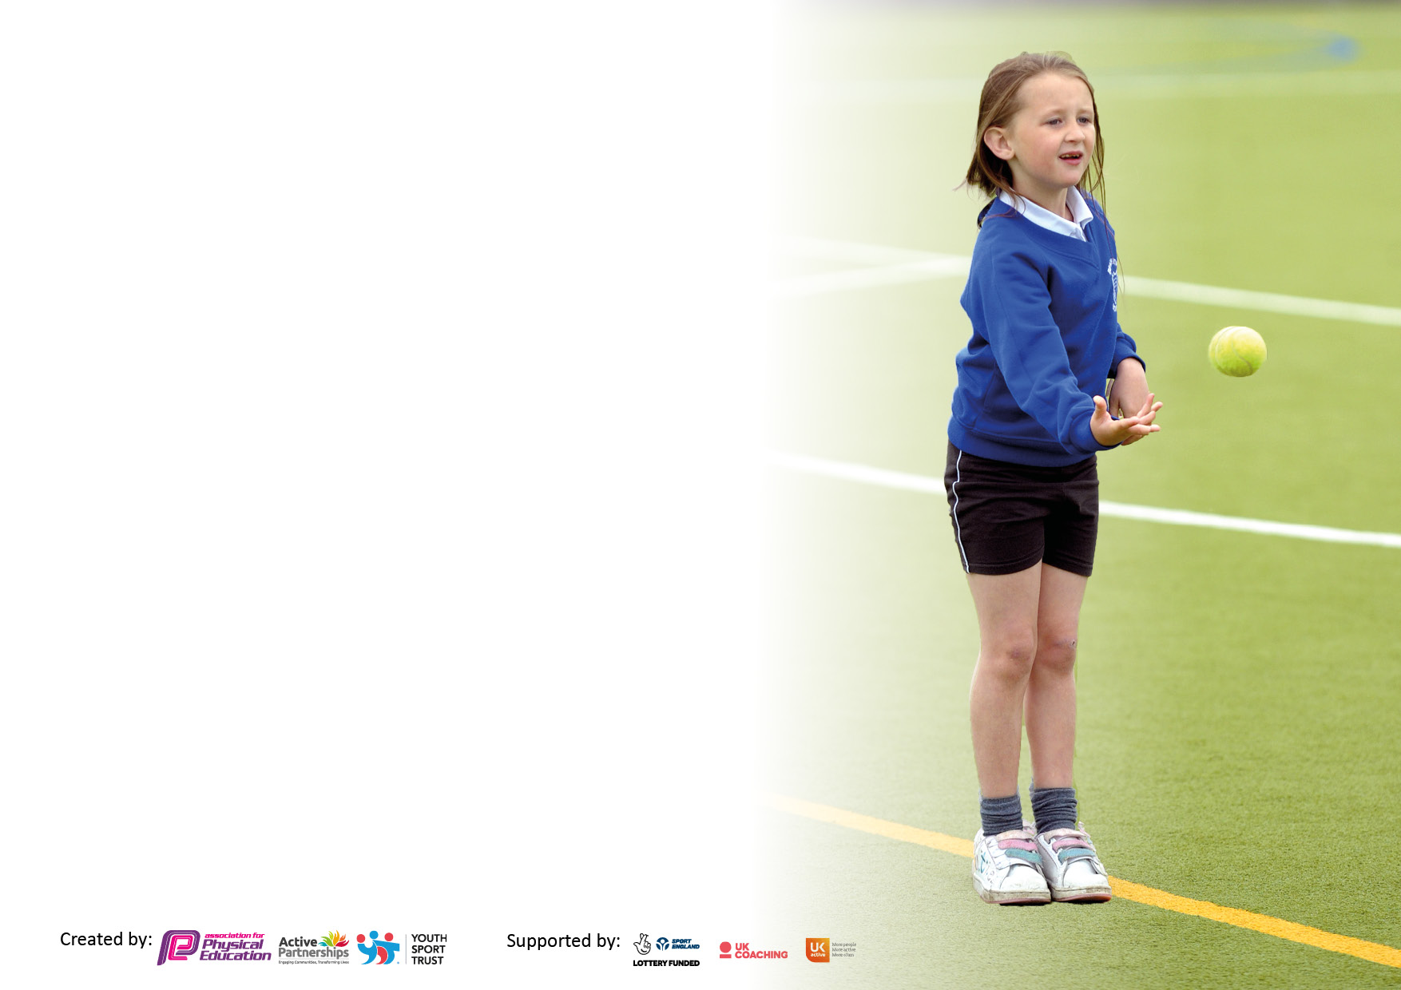

It is important that your grant is used effectively and based on school need. The Education Inspection Framework makes clear there will be a focus on ‘whether leaders and those responsible for governors all understand their respective roles and perform these in a way that enhances the effectiveness of the school’.

Under the Quality of Education Ofsted inspectors consider:
Intent - Curriculum design, coverage and appropriateness
Implementation - Curriculum delivery, Teaching (pedagogy) and Assessment
Impact - Attainment and progress

To assist schools with common transferable language this template has been developed to utilise the same three headings which should make your plans easily transferable between working documents.

Schools must use the funding to make additional and sustainable improvements to the quality of Physical Education, School Sport and Physical Activity (PESSPA) they offer. This means that you should use the Primary PE and sport premium to:

- Develop or add to the PESSPA activities that your school already offer
- Build capacity and capability within the school to ensure that improvements made now will benefit pupils joining the school in future years
- The Primary PE and sport premium should not be used to fund capital spend projects; the school’s budget should fund these.

Pleasevisitgov.ukfortherevisedDfEguidanceincludingthe5keyindicatorsacrosswhichschoolsshoulddemonstrate animprovement.Thisdocumentwillhelpyoutoreviewyourprovisionandtoreportyourspend.DfEencouragesschools to use this template as an effective way of meeting the reporting requirements of the Primary PE and sport premium.

We recommend you start by reflecting on the impact of current provision and reviewing the previous spend.

Schools are required to publish details of how they spend this funding, including any under-spend from 2019/2020, as well as on the impact it has on pupils’ PE and sport participation and attainment. All funding must be spent by 31st July 2022.

We recommend regularly updating the table and publishing it on your website throughout the year. This evidences your ongoing self-evaluation of how you are using the funding to secure maximum, sustainable impact. Final copy must be posted on your website by the end of the academic year and no later than the 31st July 2021. To see an example of how to complete the table please click HERE.
Created by: Supported by:

Details with regard to funding
Please complete the table below.

Total amount carried over from 2019/20 | £4945
Total amount allocated for 2020/21 | £19720
How much (if any) do you intend to carry over from this total fund into 2021/22? | £17248
Total amount allocated for 2021/22 | £19628
Total amount of funding for 2021/22. To be spent and reported on by 31st July 2022. | £36876
Swimming Data
Please report on your Swimming Data below.

Meeting national curriculum requirements for swimming and water safety.

N.B. Complete this section to your best ability. For example you might have practised safe self-rescue techniques on dry land which you can then transfer to the pool when school swimming restarts.
Due to exceptional circumstances priority should be given to ensuring that pupils can perform safe self rescue even if they do not fully meet the first two requirements of the NC programme of study
What percentage of your current Year 6 cohort swim competently, confidently and proficiently over a distance of at least 25 metres?  N.B. Even though your pupils may swim in another year please report on their attainment on leaving primary school at the end of the summer term 2021.  Please see note above | 64%
What percentage of your current Year 6 cohort use a range of strokes effectively [for example, front crawl, backstroke and breaststroke]?  Please see note above | 66%
What percentage of your current Year 6 cohort perform safe self-rescue in different water-based situations? | 73%
Schools can choose to use the Primary PE and sport premium to provide additional provision for swimming but this must be for activity over and above the national curriculum requirements. Have you used it in this way? | Yes

Action Plan and Budget Tracking
Capture your intended annual spend against the 5 key indicators. Clarify the success criteria and evidence of impact that you intend to measure to evaluate for pupils today and for the future.

Academic Year: 2021/22 | Total fund allocated:  £19628 2021/2022  £36876 with carry over | Date Updated: July 22
Key indicator 1: The engagement of all pupils in regular physical activity – Chief Medical Officers guidelines recommend that primary school pupils undertake at least 30 minutes of physical activity a day in school |  |  |  | Percentage of total allocation:
 |  |  |  | 60%
Intent | Implementation |  | Impact
Your school focus should be clear what you want the pupils to know and be able to do and about  what they need to learn and to  consolidate through practice: | Make sure your actions to achieve are linked to your intentions: | Funding allocated: | Evidence of impact: what do pupils now know and what can they now do? What has changed?: | Sustainability and suggested next steps:
Resources to encourage children to be active at playtime and for skills academy clubs. | Each phase had new equipment to encourage them to play sports/be active at playtimes. | £917 | Percentage of children choosing an active skills academy increasing their active week by an hour:  Autumn Term: 58%  Spring Term: 64%  Summer Term: 71% | Resources will need replaced and updating over time but we are trying to ensure we buy sustainable products.
Resources with a focus on SEND children. Developing fine and gross motor skills. | Sports coaches carried out interventions with chn who have been identified as having a physical | £123.70 | 14 children across the school have taken part in an extra physical intervention x1 break/lunchtime every 4 weeks. | Resources purchased.
Lunchtime clubs offered by qualified sports coach. | Children are encouraged to play a variety of different sports during break and lunchtimes. | £4475 | 66% of children in KS2 have attended a lunchtime sporting club over the year for at least half a term. | Dinner ladies have observed sessions so can replicate if need be.
Showing children how to be active outside of traditional methods. | Walk to school breakfast week. As part of the national walk to school month, children were encouraged to walk to school early where they could enjoy a healthy breakfast with their friends. | £200 food and drink  £200 staffing cover | 98 children accessed the event and walked to school for the week increasing their daily exercise quota and developing good habits. | Could be delivered as a sponsored event.
Encouraging children and their families to be active together. | Saturday morning event. Children and families were invited to school to run around the field together to achieve a mile or more. Other equipment was available for families to use after their run e.g. archery, tennis | £300 | Over 200 people attended the event. Parental feedback was excellent. Over 40 families stayed for the maximum three hours playing sports and exercising together. | Resourcing the event will repeat similar costs. Some costs could be recouped from selling food and drink.
Increase participation of younger children during free times using sports leaders. | Sports leader course for children.  Supporting younger children in KS1 and LKS2 to be active. | £225 sports ambassador t-shirts | X10 children undertook the course which totalled 10 hours of learning.  All KS1 and LKS2 children have been offered activities led by the older children. | Year 5 and Year 6 children took the course. The current year 5s will help to support the current year 4s to become sports leaders when they move up to their next year group in September.
Adventure trail in KS1 and KS2 playgrounds | Children have allocated times to use the adventure trail building strength and co-ordination. | £10,000 | All chn in KS1 and KS2 have access to the trails on a weekly basis. | One off payment. Trail is under warranty for any repairs which might need doing.
Goal posts | Goal posts are used daily to encourage the children to be active during break and lunchtimes. These goal posts are hard wearing and should withhold the demands of daily use. | £2000 | All children in KS2 will have access to the goal posts during break and lunchtimes. Goal posts will be used to host competitions and during after school clubs. | Long term warranty.
Scooter Day | All children from Rec-Y6 will take part in a scooter day being held by the company Scootfit. | £1320 | To be held in Autumn 2022. | This will be followed up with purchasing some and using some second hand scooters to encourage then children to be active during free times.
Basketball hoops and installation | Basketball hoops and equipment purchased and installed | £2500 | All children in KS2 will have access to hoops and basketball equipment during break and lunchtime. LSAs will support use of equipment. | One off cost.
Key indicator 2: The profile of PESSPA being raised across the school as a tool for whole school improvement |  |  |  | Percentage of total allocation:
 |  |  |  | 12%
Intent | Implementation |  | Impact
Your school focus should be clear what you want the pupils to know and be able to do and about  what they need to learn and to  consolidate through practice: | Make sure your actions to achieve are linked to your intentions: | Funding allocated: | Evidence of impact: what do pupils now know and what can they now do? What has changed?: | Sustainability and suggested next steps:
Increase children’s interest in sports and gaining knowledge. Provide children with different role models. | Books and display board | £1143.68 | Children have access to and read the books daily | Books will need updated every few years.
Active teaching and learning | Teach Active Maths | £575 | KS2 children engaged in x1 active maths lesson per fortnight. | Being embedded into curriculum. Monitored by PE and Maths lead.

Key indicator 3: Increased confidence, knowledge and skills of all staff in teaching PE and sport |  |  |  | Percentage of total allocation:
 |  |  |  | 3%
Intent | Implementation |  | Impact
Your school focus should be clear | Make sure your actions to | Funding | Evidence of impact: what do | Sustainability and suggested
what you want the pupils to know | achieve are linked to your | allocated: | pupils now know and what | next steps:
and be able to do and about | intentions: |  | can they now do? What has
what they need to learn and to |  |  | changed?:
consolidate through practice:
CPD | Teaching Assistant and Dinner lady training offered by sports coaches  Sports Coach gymnastics training  Youth Sports Trust membership | £300  £600  £210 | Staff lead physical activities daily during break and lunchtimes. All KS2 children have the opportunity to be involved.  Sports coach has used skills when delivering the gymnastics element of the curriculum. All KS2 children have experienced gymnastics lessons as part of the PE curriculum. 32 children have had an extra 45 mins per week of gymnastics across the year  PE Lead and inhouse sports coach have accessed resources in order to support development of PE across the school. | Refresher training will be offered next year. Experienced members of staff to offer in house training to new starters.  Training has been established and put into practice.  Knowledge gained and implemented.
Key indicator 4: Broader experience of a range of sports and activities offered to all pupils |  |  |  | Percentage of total allocation:
 |  |  |  | 20%
Intent | Implementation |  | Impact
Your school focus should be clear | Make sure your actions to | Funding | Evidence of impact: what do | Sustainability and suggested
what you want the pupils to know | achieve are linked to your | allocated: | pupils now know and what | next steps:
and be able to do and about | intentions: |  | can they now do? What has
what they need to learn and to |  |  | changed?:
consolidate through practice:
Rugby coaching by ex-professional rugby player | Ashley Johnson, rugby coach, offered a club for children x1 per week. | £220 | 40 children played an extra hour of rugby per week for the summer term.
To enable children to leave primary school with the minimum swimming requirements. | Two week intensive course for Y6 children who hadn’t already met swimming criteria. | £2800 | 33 children attended the two-week course. All children improved in their confidence in the water.
After looking at internal data, tennis was chosen by PE team as a focus to improve not only tennis skills but hand-eye co-ordination. | Tennis equipment  Coventry and North Warwickshire Membership | £1441.65  £20 | All children in KS2 have had access to the new tennis equipment during curriculum time but also break and lunchtime clubs. | Equipment with be kept securely in PE Shed and PE leaders will ensure equipment is returned and stored correctly.
Exposing children to a different way of keeping active and learning skills to use in real life situations. | Orienteering kit purchased and school mapped out. | £2280 | Orienteering system has been used for both PE and other areas of the curriculum. Teaching children how to be active and learn at the same time. Teachers will use system x1 every three weeks. A group of children will use the system for one hour every week. | Purchased and set up.
Exposing children on how to use physical activity as entertainment | Circus kits | £349 | Kits used during Skills Academy which adds an extra hour of physical activity a week for 20 children each half term. | Kits managed and monitored by teacher and sports leaders.

Key indicator 5: Increased participation in competitive sport |  |  |  | Percentage of total allocation:
 |  |  |  | 5%
Intent | Implementation |  | Impact
Your school focus should be clear | Make sure your actions to | Funding | Evidence of impact: what do | Sustainability and suggested
what you want the pupils to know | achieve are linked to your | allocated: | pupils now know and what | next steps:
and be able to do and about | intentions: |  | can they now do? What has
what they need to learn and to |  |  | changed?:
consolidate through practice:
Increase amount of children taking part in competitive events against other schools. | Transport to competitive events | £551.68 | 48% of children have taken part in a competitive sport and represented the school. | Transporting children to and from events will always be a cost to the school.
Continue to increase intra-school competitions. | Competitions run by sports coaches at lunchtime throughout the year which contributed towards end of the year sports day points. | £4475 (cost covered in KI1) | 100% of children have taken part in intra-school competitions. | Competitions organised and deliver by PE lead and sports coaches.
Encourage children to take part in competitive sports against other schools to inspire them and increase resilience. | Sainsburys Games led and organised remotely by SGO’s. | £250  £400 to support cover for internal sports coach to organise events. | Children across all key stages have taken part in competitions organised and delivered by SGO and with the network.  Gymnastics, rugby, football, tennis, | Will continue to be part of Sainsburys Games as it is well organised and provides a lot of opportunities for the children.
Encourage SEND chn to part in competitions against other schools. | Network event organised with eight other schools solely for SEND children. | £200 High ratio of staff required.  £75 Transport to event. | 12 children across KS1 and KS2 took part in SEND event. | Offering to be the host school will reduce costs next year.

Signed off by
Head Teacher: | Ian Taylor
Date: | 23rd July 2022
Subject Leader: | Carly Appleton
Date: | 23rd July 2022
Governor: | Claire Saunders
Date: | 30th July 2022

