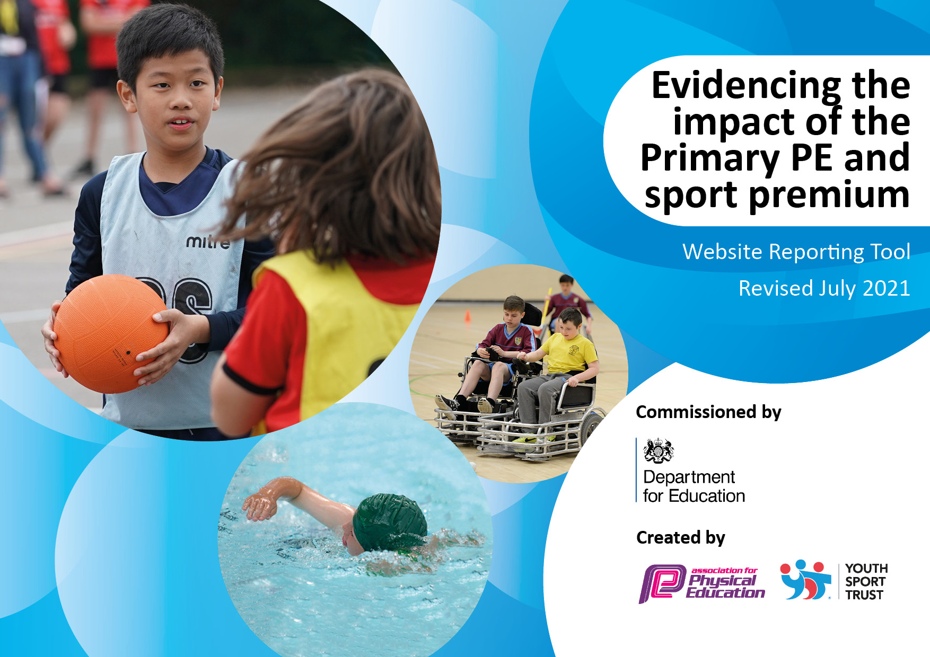
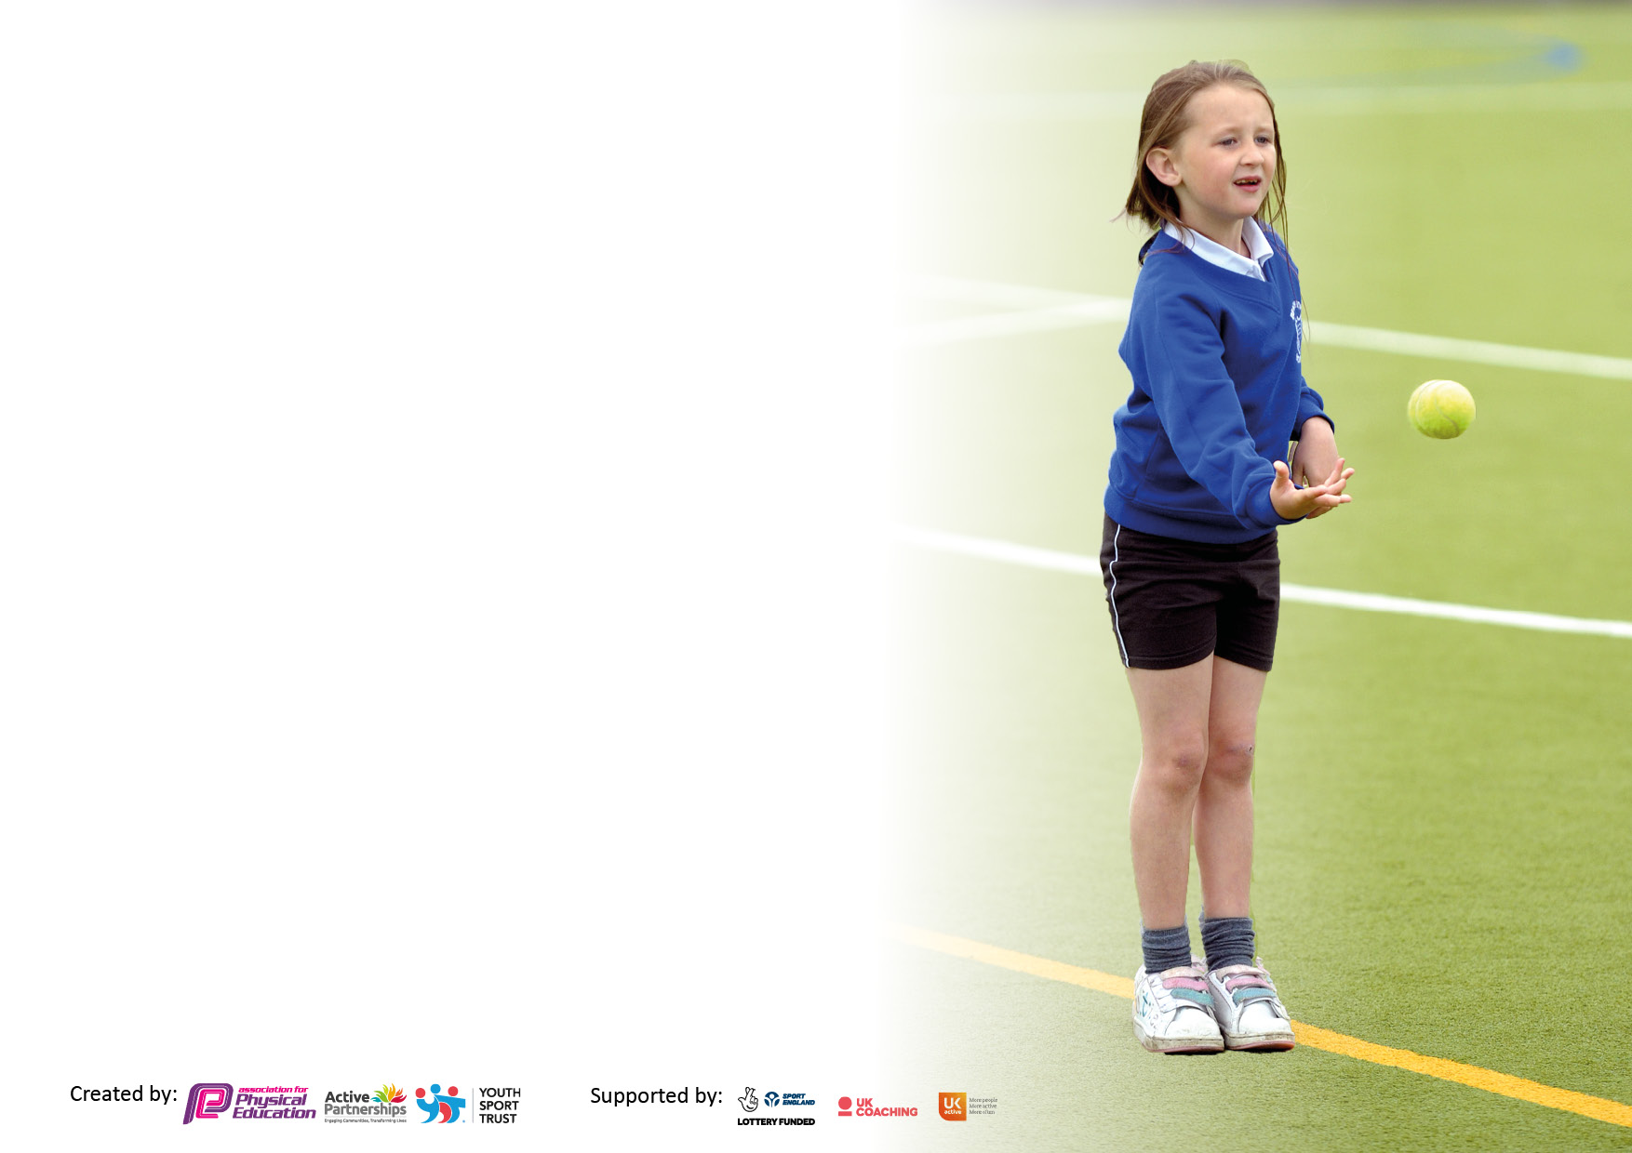

It is important that your grant is used effectively and based on school need. The Education Inspection Framework makes clear there will be a focus on ‘whether leaders and those responsible for governors all understand their respective roles and perform these in a way that enhances the effectiveness of the school’.

Under the Quality of Education Ofsted inspectors consider:
Intent - Curriculum design, coverage and appropriateness
Implementation - Curriculum delivery, Teaching (pedagogy) and Assessment
Impact - Attainment and progress

To assist schools with common transferable language this template has been developed to utilise the same three headings which should make your plans easily transferable between working documents.

Schools must use the funding to make additional and sustainable improvements to the quality of Physical Education, School Sport and Physical Activity (PESSPA) they offer. This means that you should use the Primary PE and sport premium to:

- Develop or add to the PESSPA activities that your school already offer
- Build capacity and capability within the school to ensure that improvements made now will benefit pupils joining the school in future years
- The Primary PE and sport premium should not be used to fund capital spend projects; the school’s budget should fund these.

Pleasevisitgov.ukfortherevisedDfEguidanceincludingthe5keyindicatorsacrosswhichschoolsshoulddemonstrate animprovement.Thisdocumentwillhelpyoutoreviewyourprovisionandtoreportyourspend.DfEencouragesschools to use this template as an effective way of meeting the reporting requirements of the Primary PE and sport premium.

We recommend you start by reflecting on the impact of current provision and reviewing the previous spend.

Schools are required to publish details of how they spend this funding, including any under-spend from 2019/2020, as well as on the impact it has on pupils’ PE and sport participation and attainment. All funding must be spent by 31st July 2022.

We recommend regularly updating the table and publishing it on your website throughout the year. This evidences your ongoing self-evaluation of how you are using the funding to secure maximum, sustainable impact. Final copy must be posted on your website by the end of the academic year and no later than the 31st July 2021. To see an example of how to complete the table please click HERE.
Created by: Supported by:

Details with regard to funding
Please complete the table below.

Total amount carried over from 2019/20 | £4945
Total amount allocated for 2020/21 | £19,720
How much (if any) do you intend to carry over from this total fund into 2021/22? | £17,248
Total amount allocated for 2021/22 | £19,720
Total amount of funding for 2021/22. To be spent and reported on by 31st July 2022. | £36,968
Swimming Data
Please report on your Swimming Data below.

Meeting national curriculum requirements for swimming and water safety.

N.B. Complete this section to your best ability. For example you might have practised safe self-rescue techniques on dry land which you can then transfer to the pool when school swimming restarts.
Due to exceptional circumstances priority should be given to ensuring that pupils can perform safe self rescue even if they do not fully meet the first two requirements of the NC programme of study
What percentage of your current Year 6 cohort swim competently, confidently and proficiently over a distance of at least 25 metres?  N.B. Even though your pupils may swim in another year please report on their attainment on leaving primary school at the end of the summer term 2020.  Please see note above | 75%
What percentage of your current Year 6 cohort use a range of strokes effectively [for example, front crawl, backstroke and breaststroke]?  Please see note above | 77%
What percentage of your current Year 6 cohort perform safe self-rescue in different water-based situations? | 66.6%
Schools can choose to use the Primary PE and sport premium to provide additional provision for swimming but this must be for activity over and above the national curriculum requirements. Have you used it in this way? | Yes

Action Plan and Budget Tracking
Capture your intended annual spend against the 5 key indicators. Clarify the success criteria and evidence of impact that you intend to measure to evaluate for pupils today and for the future.

Academic Year: 2020/21 | Total fund allocated: | Date Updated:
Key indicator 1: The engagement of all pupils in regular physical activity – Chief Medical Officers guidelines recommend that primary school pupils undertake at least 30 minutes of physical activity a day in school |  |  |  | Percentage of total allocation:
 |  |  |  | 5.2%
Intent | Implementation |  | Impact
Your school focus should be clear what you want the pupils to know and be able to do and about  what they need to learn and to  consolidate through practice: | Make sure your actions to achieve are linked to your intentions: | Funding allocated: | Evidence of impact: what do pupils now know and what can they now do? What has changed?: | Sustainability and suggested next steps:
Resources to encourage the children to be active at playtimes.  Being active in non-traditional ways.  Increase fitness levels after last year’s lockdown. Different bubbles to be able to be active at the same time. | Each bubble had their own set of equipment.  Alternative equipment used to show children how to be active in alternative ways.  New goal posts and balls assigned to each year group bubble. | £328  £175  £533 | All children were active at play-times and lunchtimes using the equipment provided for them. Staff saw an increase in use and a reduction in behavioural issues.  All children across the school have been exposed to alternative ways to be active and have engaged in these activities during their free time.  After talking to the children 87% of KS2 said they were most looking forward to playing football with their friends. The post and balls have been used daily. | We will continue to have class equipment as taking responsibility for their own set encouraged the children to use it.
Key indicator 2: The profile of PESSPA being raised across the school as a tool for whole school improvement |  |  |  | Percentage of total allocation:
 |  |  |  | 14.22%
Intent | Implementation |  | Impact
Your school focus should be clear what you want the pupils to know and be able to do and about  what they need to learn and to  consolidate through practice: | Make sure your actions to achieve are linked to your intentions: | Funding allocated: | Evidence of impact: what do pupils now know and what can they now do? What has changed?: | Sustainability and suggested next steps:
Improvement of fine and gross motor skills in target year groups EYFS and Y2. | A review of each year group revealed the physical needs within these year groups and in collaboration with the teachers, SENCo and PE team equipment was purchased to develop key physical skills. | £160 Y2 and EYFS equipment | Data from EYFS and Y2 was impacted by bubble closures and national lockdown. However year group teachers report a positive impact on fine and gross motor skills. | Review again next year to target key children/year groups.
Real PE three years curriculum subscription. | Curriculum plan which focuses on the fundamental movement skills as well as developing the child holistically. | £1875 | Clear vision for PE for the next three years. Training for PE lead, coaches and staff is incorporated into this cost.
Real PE equipment | Specific equipment required to enable high quality lessons and for staff to follow the Real PE lessons | £80 | High quality PE lessons delivered. | Ensure equipment is stored securely to prolong usage.
Active teaching and learning | Teach Active Maths | £690 | KS2 children engage in (on average) x1 active maths lesson per fortnight. | Practice to continue to be embedded into maths curriculum. Monitored by PE and Maths Lead.

Key indicator 3: Increased confidence, knowledge and skills of all staff in teaching PE and sport |  |  |  | Percentage of total allocation:
 |  |  |  | 2.8%
Intent | Implementation |  | Impact
Your school focus should be clear | Make sure your actions to | Funding | Evidence of impact: what do | Sustainability and suggested
what you want the pupils to know | achieve are linked to your | allocated: | pupils now know and what | next steps:
and be able to do and about | intentions: |  | can they now do? What has
what they need to learn and to |  |  | changed?:
consolidate through practice:
Real PE Leaders online course and resources. | PE Subject lead attended an online course and will establish a leaders programme for children in Y5 and Y6 next academic year. | £235 | To be offered next academic year. | Real leaders to inspire children to develop a love for sport and physical activity as well as developing their responsibility.
Accelerated learning – a deep dive into PE (online course for PE lead). | Improved subject knowledge for PE subject lead to ensure we are meeting the demands of the curriculum | £48 | Evidence and information shared with internal and external PE coaches. | Keep up to date with any changes to PE curriculum and requirements of sports premium funding.
Key indicator 4: Broader experience of a range of sports and activities offered to all pupils |  |  |  | Percentage of total allocation:
 |  |  |  | 8.5%
Intent | Implementation |  | Impact
Your school focus should be clear | Make sure your actions to | Funding | Evidence of impact: what do | Sustainability and suggested
what you want the pupils to know | achieve are linked to your | allocated: | pupils now know and what | next steps:
and be able to do and about | intentions: |  | can they now do? What has
what they need to learn and to |  |  | changed?:
consolidate through practice:
To provide new experiences to support a lifelong engagement in sports and activities:  Skills Academy Clubs  Extra-curricular Clubs  Playtime physical activities | Clubs offered to ensure high attendance but also providing opportunities to learn new skills. | £100  Some funding allocated in KI1 | Skills Academy sessions  76% of KS2 children chose to attend a physically active club providing an extra 1 hours activity a week. | Review restrictions in September and ensure a variety of clubs are on offer to the children. Continue to encourage staff to offer physically active clubs linked to their passion.
To enable children to leave primary school with the minimum swimming requirements. | Two-week intensive course for Y6 children who hadn’t met the requirements in Y4. | Lessons  £850  Transport £725 | All children improved in their confidence in the water.  4 children could swim 25m and 5 children could use a range of strokes who couldn’t before these lessons. | Continue to use local swimming baths to enable children to walk back therefore keeping travel and staffing costs lower.

Key indicator 5: Increased participation in competitive sport |  |  |  | Percentage of total allocation:
 |  |  |  | 7%
Intent | Implementation |  | Impact
Your school focus should be clear | Make sure your actions to | Funding | Evidence of impact: what do | Sustainability and suggested
what you want the pupils to know | achieve are linked to your | allocated: | pupils now know and what | next steps:
and be able to do and about | intentions: |  | can they now do? What has
what they need to learn and to |  |  | changed?:
consolidate through practice:
Continue to increase intra-school competitions. | Competitions run by sports coaches at lunchtimes throughout the year (whilst in school) which contributed towards sports day points at the end of the year. | £675 external sports coach | All children in KS1 and KS2 were offered a lunchtime club.  Due to bubble closures at different points throughout the year in different year groups, the data is not reflective of the impact. This will be reviewed again next academic year. | Continue to offer lunchtime clubs led by Sports coach. Provide training for staff on duty at lunchtime to provide other clubs for children.
Encourage children to take part in competitive sports against other schools to inspire them and increase resilience. | Sainsburys Games led and organised remotely by SGO’s. | £300  £400 to support cover for internal sports coach to organise. | All children in Years 1-6 have taken part in virtual challenges set my SGO’s. | Remain involved in events organised by SGO’s next year.

Signed off by
Head Teacher: | Ian Taylor
Date: | 28th July 2021
Subject Leader: | Carly Appleton
Date: | 28th July 2021
Governor: | Simon Miller
Date: | 28th July 2021

