Important Information
Curriculum Leaflets and Reports for Parents

Dear parents and carers,
I am writing to inform you that we are changing the way we report to parents. We will now be sending home two shorter, but more succinct reports, twice a year instead of one long end of year report.
The new reports will go out to parents in Spring Term 1 and Summer Term 2. The reports will give information about children’s progress, attainment and effort in all national curriculum subjects and will include comments for English and Maths, a personal comment and a comment from the Headteacher.
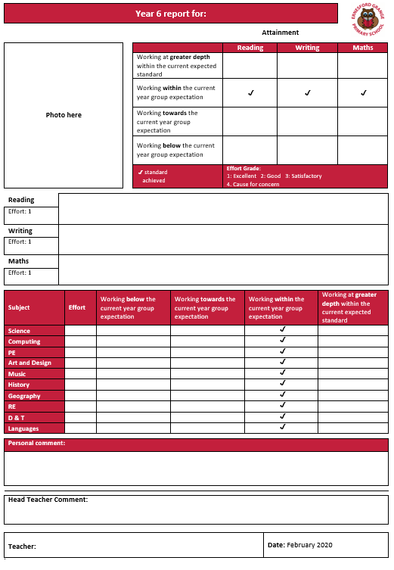
We have removed information about the curriculum and what the children have been learning about from the reports as this information is now fully available on the school website in the ‘About Us’ then the ‘Our School Curriculum Section’. From now on, we will also regularly send home curriculum leaflets that summarise what the children are learning about each half term to help keep you informed about their learning. These leaflets will be available on the school website too. The blogs on the homepage of the website give you an insight into what the children have been learning about.
We have taken this decision based on a range of parental feedback and questionnaires, but mainly because we think it is important to formally keep you informed of your child’s progress halfway through the year and not just at the end, so any issues you can help with are clearly identified.
The reports will be considerably shorter, but will tell you everything you need to know about your child’s attainment, effort and any areas of concern.
The screenshot shows a template of how your child’s mid-year report will look. This report will then form the basis for your discussions at the parent teacher consultation evening in the spring term. The meetings will take place shortly after the mid-year report is sent home.

Yours Sincerely,

Mr I Taylor
Headteacher

